

|  |  |
| --- | --- |
| **Intake: APD1F2409CS(CYB)** | **Module Code: CT046-3-1-ISTF** |

|  |  |  |
| --- | --- | --- |
| **HAND OUT DATE: Thursday, 24 April 2025 Week 6** |  |  |
| **SUBMISSION DATE: Thursday, 26 June 2025 Week 14** |  |  |

**TITLE:**

***MEMORY ACQUISITION AND FORENSIC INVESTIGATION***

**Module Lecturer: Ts. Muhammad Amin Sahari**

**GROUP NAME 14**

|  |  |
| --- | --- |
| **AHMED MIRAHUSAIN ALVI** | **TP084807** |
| **ABDALLAH MOHAMED MAHMOUD MOHAMED** | **TP085097** |
| **SULTAN ABDULLA OMAR TAKRORI** | **TP085327** |
| **BADR MAHDI MUBARAK AL-AMRI** | **TP083084** |
| **MOHAMED ABA SAID** | **TP082376** |
| **MOHAMED ABDIFATAH ALI** | **TP082459** |
| **MOHAMMED YOUSEF MOHAMMED MOHAMMED** | **TP085042** |
| **MAHRUS SHAMSUL AHSAN** | **TP085562** |

TABLE OF CONTENTS

CHAPTER 1: INTRODUCTION 1

CHAPTER 2: EVIDENCE ACQUISITION & PRESERVATION 2

**2.1** Forensics Tools Used 2

**2.2** Data Acquisition 3

CHAPTER 3: RAM & HDD DATA EXTRACTION 5

**3.1** Load Infected Windows 10 using VMware 5

**3.2** Capture Memory using Magnet Ram Capture 11

**3.3** Loading MRC Image file into Volatility Workbench V3.0 14

**3.4** New Case Creation and HDD data extraction using Autopsy 4.22.1 17

CHAPTER 4: RAM & HDD IMAGE ANALYSIS 21

**4.1** Ram Analysis using PassMark Volatility Workbench V3.0 21

**4.1.1** Potential Malware Detections from Command Line Analysis 21

**4.1.2** Operating System Information from Memory Dump 22

**4.1.3** Malware Analysis via windows.malfind.Malfind 23

**4.1.4** User Session Information for rsasws.exe and wap.exe 25

**4.1.5** Analysing Open Handles of wap.exe and rsasws.exe 26

**4.1.6** Analysing Security Identifiers(SIDs) of wap.exe and rsaws.exe 27

**4.2** HDD Analysis using Autopsy 4.22.1 28

**4.2.1** wap.exe 28

**4.2.2** rsaws.exe 29

**4.2.3** FakeClient.exe 30

**4.2.4** TunMirror.exe 31

**4.2.5** KMSAuto Net.exe 32

**4.2.6** DLLInjector v2.exe 33

**4.2.7** updsto.exe 34

**4.2.8** KMSCleaner.exe 35

**4.2.9** KMSSS.exe 36

**4.2.10** Ioder.exe 37

**4.2.11** win10drivetest(Demo).exe 38

**4.2.12** filedat.dat 39

**4.2.13** Final_Test.pdf 40

CHAPTER 5: TECHNICAL REPORT 41

**5.1** Executive Summary 41

**5.2** Relevant Findings 41

**5.2.1** Keylogger 41

**5.2.2** KMS 42

**5.2.3** Trojans 43

**5.3** Steps to Mitigate Risks or Prevent Recurrence 44

**5.3.1** Stricter Control Over Software installation 44

**5.3.2** Better Endpoint Protection and Monitoring 44

**5.3.3** Mandatory User Training and Awareness 45

CONCLUSION 46

REFERENCES 47

WORKLOAD MATRIX 48

CHAPTER 1: INTRODUCTION

In this paper, we adopted the Digital Forensic Investigation Methodology (DFIM).In the Acquisition and Preservation phase, our instructor provided us with a Windows 10 image. This allowed us to maintain the base data in its original state, establish a chain of custody, and document our steps at that level. In the Discovery and Extraction Phase, We booted the infected windows image to the VMware and we ran Magnet RAM Capture. We performed Analysis and Validation by applying Tools such as Autopsy in examining the collected data. We hashed all the binary files that were suspicious and uploaded to VirusTotal and Hybrid Analysis to see if the hashes can be found as a malware. We validated the results against existing security engines. Finally, we did the Reconstruction and Presentation phase, where we structured our results as an illustrious timeline and narrative flows to make evident the malware’s dynamic. (Computer Forensics, 2024)

Figure 1 Digital Forensic Investigation Model (DFIM)

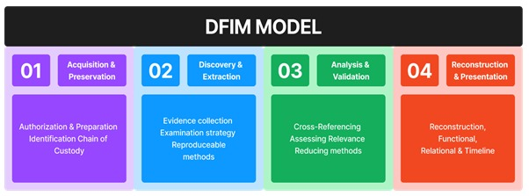

CHAPTER 2: EVIDENCE ACQUISITION & PRESERVATION

**2.1** Forensics Tools Used

|  |  |
| --- | --- |
| **Tool** | **Tool Description** |
|  | **Magnet RAM Capture** |
| Magnet RAM Capture is a free imaging tool designed to capture the physical memory of a suspect’s computer, allowing investigators to recover and analyze valuable artifacts that are often only found in memory. Evidence that can be found in RAM includes processes and programs running on the system, network connections, evidence of malware intrusion, registry hives, usernames and passwords, decrypted files and keys, and evidence of activity not typically stored on the local hard disk. (Magnet RAM Capture, n.d.) |
|  | **Autopsy V4.21.0** |
| By implementing system image files, Autopsy is an open-source, cross-platform digital forensics toolkit that offers a wide range of features and capabilities to aid investigators in the retrieval and analysis of digital evidence also known as The Sleuth Kit, is a widely used open-source digital forensics tool that provides a comprehensive suite of features for forensic investigators. |
|  | **Volatility Work Bench** |
| Volatility Workbench is a graphical user interface (GUI) for the Volatility Tool. Volatility is a command line memory analysis and forensics tool for extracting artifacts from memory dumps. Volatility Workbench is free, open source and runs in Windows. It provides several advantages over the command line version. (The Volatility Foundation, 2025) |

|  |  |
| --- | --- |
|  | **VirusTotal** |
| VirusTotal inspects items with over 70 antivirus scanners and URL/domain blocklisting services, in addition to a myriad of tools to extract signals from the studied content. Any user can select a file from their computer using their browser and send it to VirusTotal. VirusTotal offers several file submission methods, including the primary public web interface, desktop uploaders, browser extensions and a programmatic API. (virustotal, n.d.) |
|  | **Hybrid Analysis** |
| Hybrid Analysis is an online tool that checks if a file or website is harmful by running it in a sandbox—a safe, virtual environment where it can’t affect real systems. It watches how the file behaves, such as what it tries to change, what it connects to, or if it acts like malware. It then gives a report showing whether the file is safe or suspicious. (Hybird Analysis, n.d.) |

## **2.2** Data Acquisition

Figure Infected Windows 10 Disk Image Stored on USB Drive

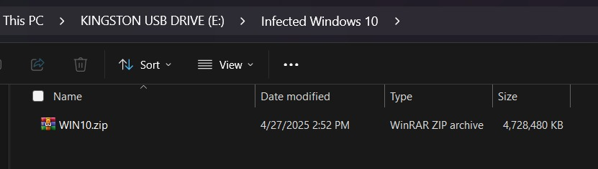The forensic investigation depicted in Figure 2 shows a Windows 10 virtual PC infected with malware and the illustrated image was a representation of the data acquisition process. It represents the directory of a USB flash drive (E:) with a compressed WinRAR zip archive file WIN10.zip. This zip file contains the virtual machine disk file (.vmdk) which will be studied. The date of the last change in the file is April 27, 2025, and its size, 4,728,480 KB, is stored.

Figure HashMyFiles v2.50 Showing Cryptographic Hashes for WIN10.zip

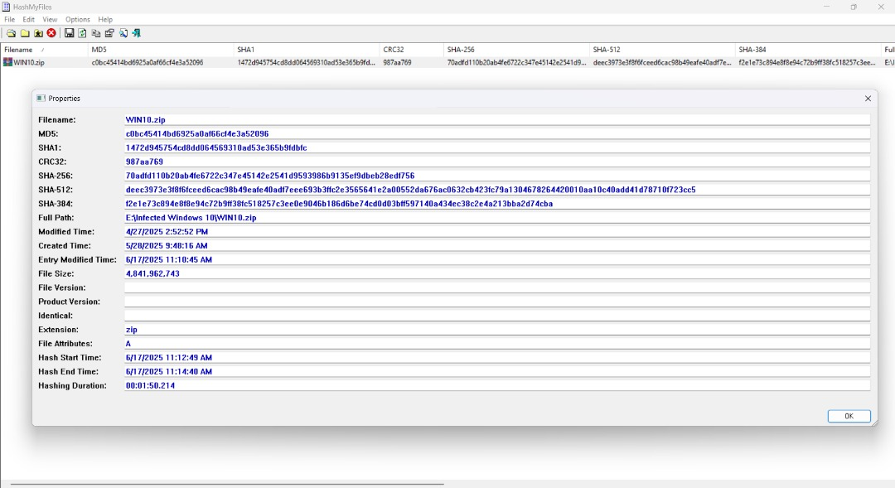

Figure 3 is a visual representation of how HashMyFiles v2.50 is used in establishing the integrity of a file named WIN10.zip in the framework of a forensic test. The utility created the following cryptographic hash in its execution: MD5, SHA1, CRC32, SHA-256, SHA-512 and SHA-384. These figures are like digital fingerprints to ensure there is no altering or tampering with the file. The file destination is E:\Infected Windows 10 with its size at 4.84 GB (4,841,962,743 bytes). The hash creation started 11:12:49 AM, and ended at 11:14:40 AM, which was roughly 1 minute and 50 seconds. Hash functionality that applies to a variety of algorithms makes the data validation more reliable and fits the forensic standards because of the file integrity and chain of custody.

CHAPTER 3: RAM & HDD DATA EXTRACTION

**3.1** Load Infected Windows 10 using VMware

Step 1: [Download](https://support.broadcom.com/group/ecx/productfiles?subFamily=VMware%20Workstation%20Pro&displayGroup=VMware%20Workstation%20Pro%2017.0%20for%20Windows&release=17.6.3&os=&servicePk=&language=EN&freeDownloads=true) the VMWare Workstation Player/Pro latest release

Figure VMware Workstation Pro Download Page

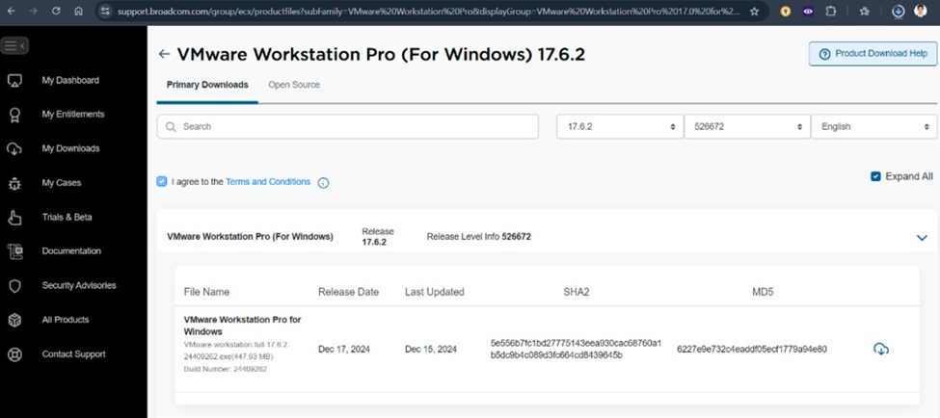

Step 2: Save the file and let it download.

Figure File explorer prompt to save the VMware Workstation v17.6.2 .exe file

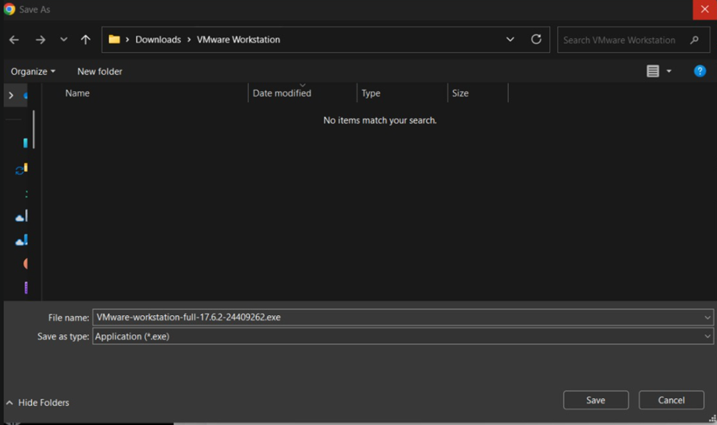

Step 3: Launch the installer and Click Next

Figure VMware Workstation 17 Player Installation Wizard Interface

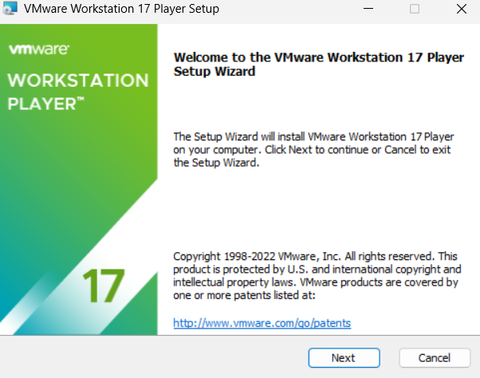

Step 4: Accept the End User License Agreement (EULA) then click next.

Figure VMware Workstation EULA Prompt

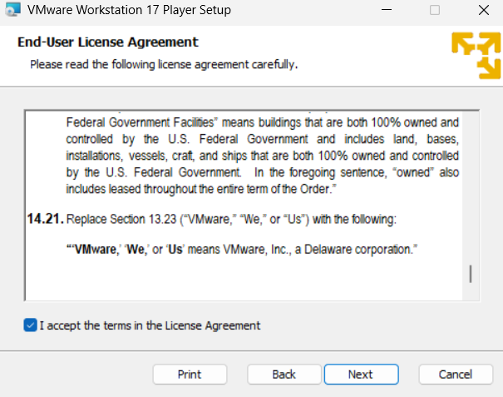

Step 5: Add VMware Workstation Console tools into system PATH and Click Next.

Figure VMware Workstation custom setup Wizard

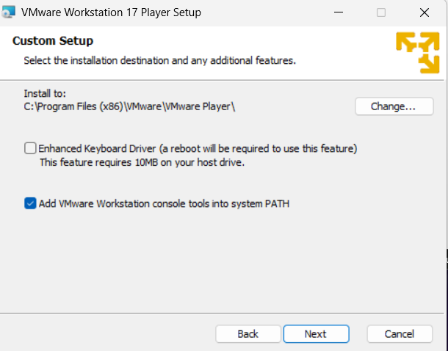

Step 6: Click Install and wait for installation to finish

Figure VMware Workstation Setup Installation wizard

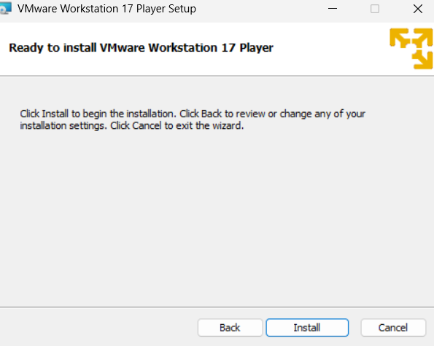

Step 7: Launch VMware Workstation 17 Player.

Figure VMware Workstation 17 Player in Windows Menu

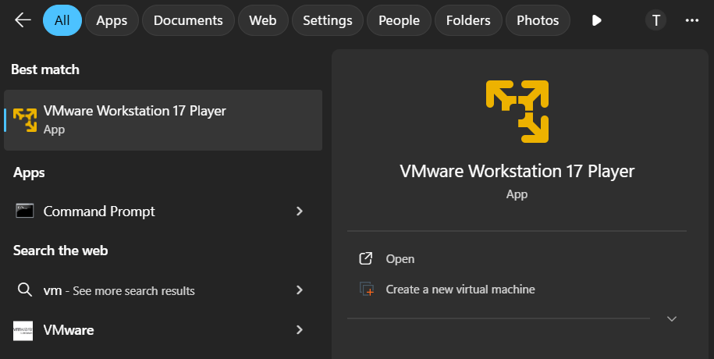

Step 8: Select “Use VMware Workstation 17 Player for free for non-commercial use” and click continue.

Figure VMware Workstation 17 Player Welcome Prompt

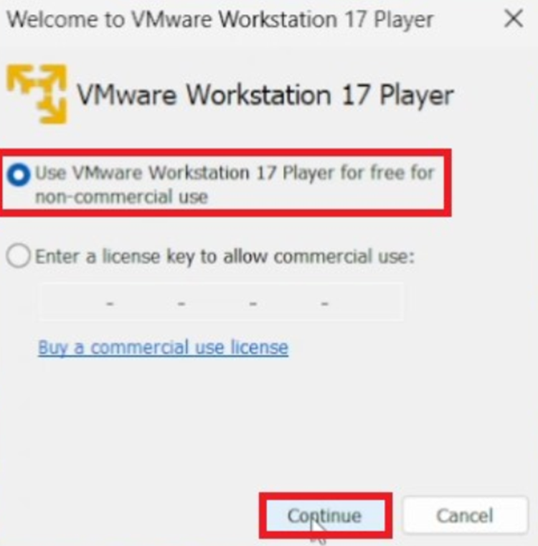

VMware Workstation 17 Player Installation is now Completed.

Figure VMware Workstation 17 Player User Interface

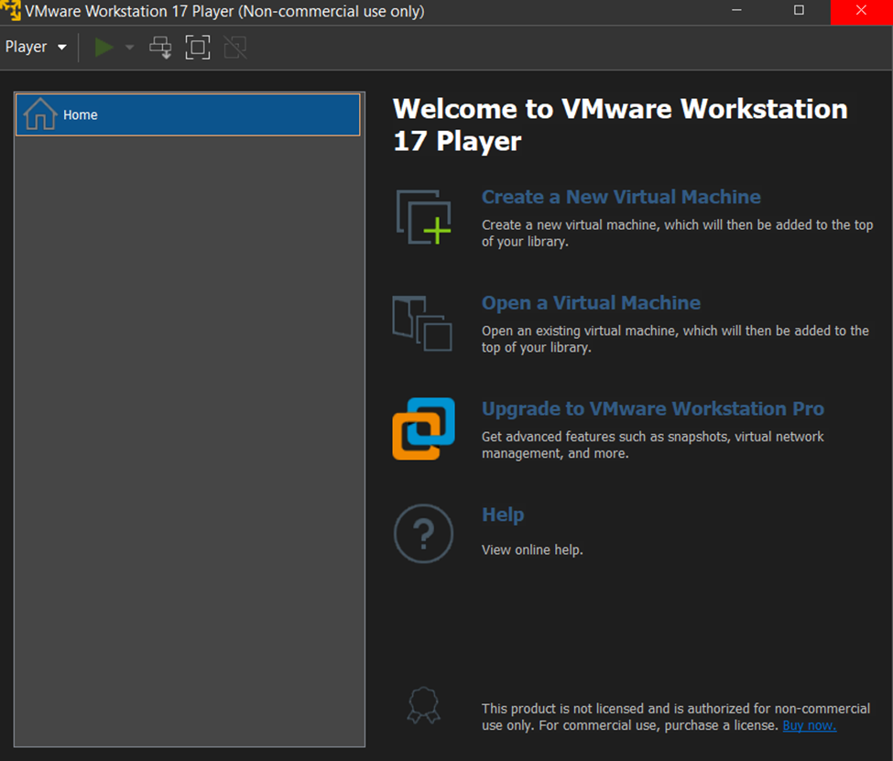

Step 9: Select “Open a Virtual Machine”

Figure VMware Interface to open a Virtual machine

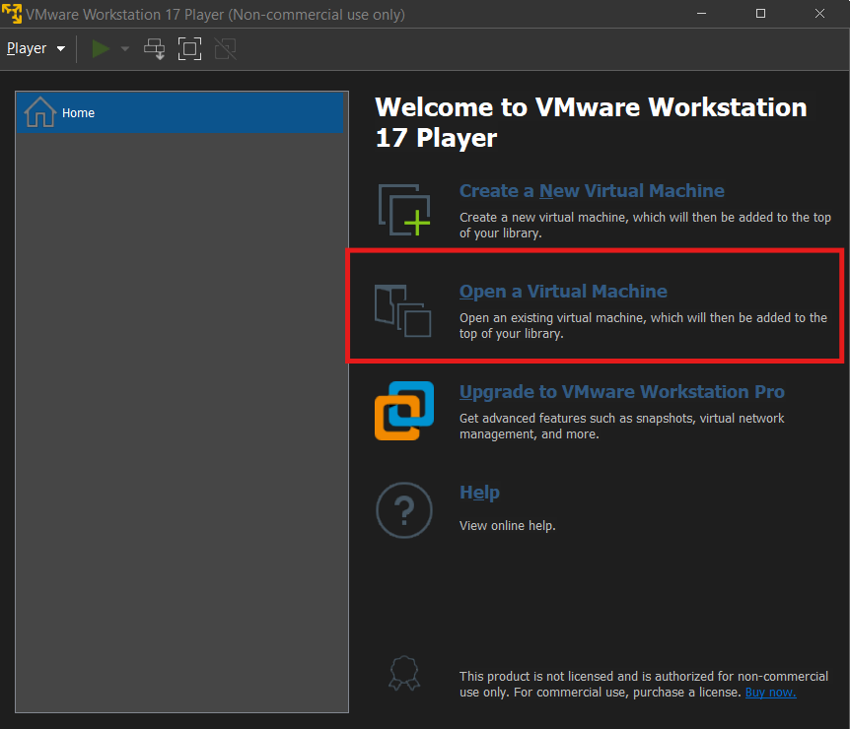

Step 10: Select the Windows 10 (Infected).vmx file

Figure File explorer displaying contents of WIN10LAB folder

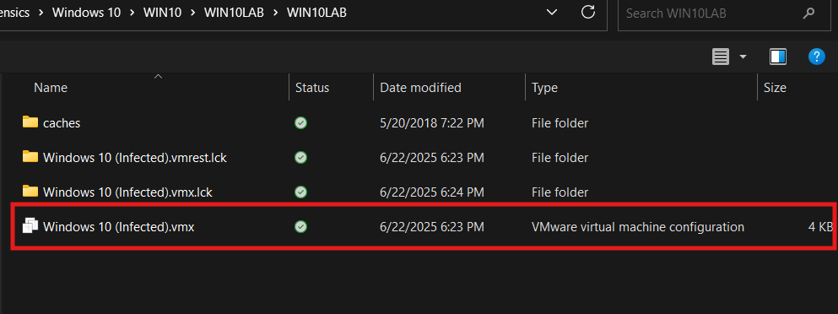

Step 11: Click “Play virtual machine”

Figure shows Window 10 (Infected) added to VMware Library

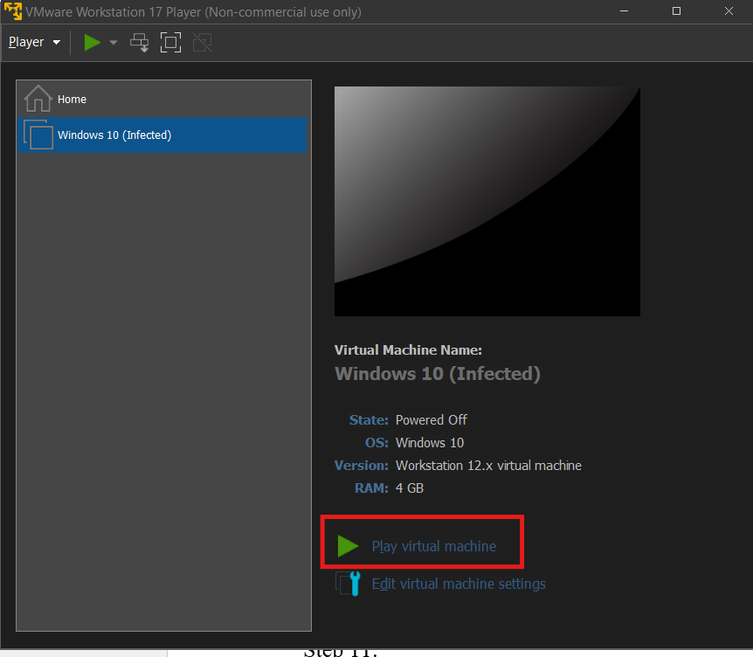

The Infected Windows 10 is now Successfully Loaded Using VMware.

Figure shows Lock screen of Windows 10 (Infected)

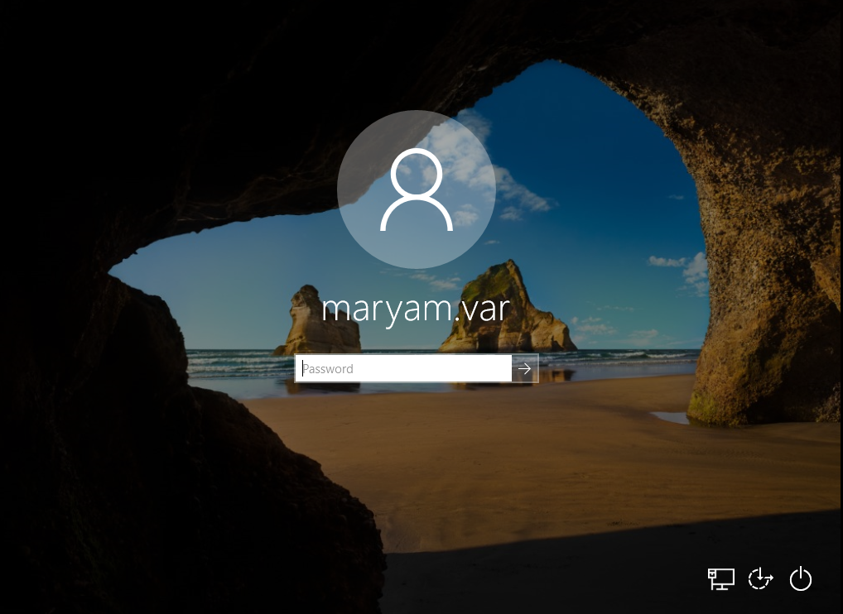

**3.2** Capture Memory using Magnet Ram Capture

Step 1: launch the Magnet Ram Capture in the infected Windows 10 Virtual Machine

Figure Magnet RAM Capture v1.2.0 Main Interface for Initiating Memory Acquisition

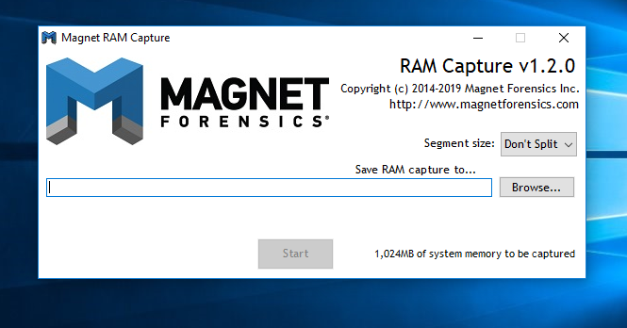

Step 2: make sure you select in the Segment size section “Don’t Split” so that the RAM capture will be saved as a single, contiguous file

Figure Magnet RAM Capture v1.2.0 "Segment size" Options for Memory Dump

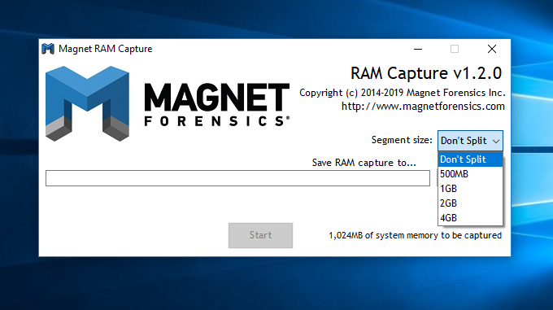

Step 3: click browse to select the directory to save the memory dump file

Figure Magnet RAM Capture "Save As" Dialog Box for Memory Dump

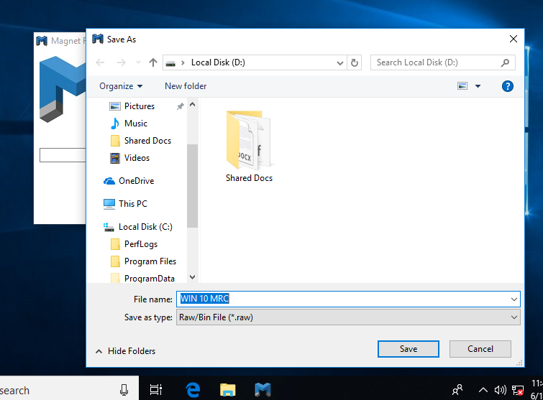

Step 4: after selecting your desired directory, it should show in the text box

Figure Magnet RAM Capture Interface Showing Output Path Configuration

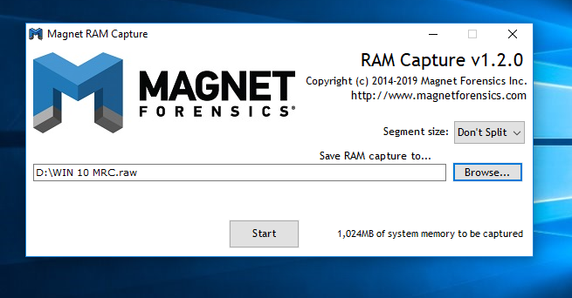

Step 5: then Click Start to Proceed with Capturing The RAM. It will then be done after the program bar finishes running

Figure Magnet RAM Capture Progress Bar During Memory Acquisition

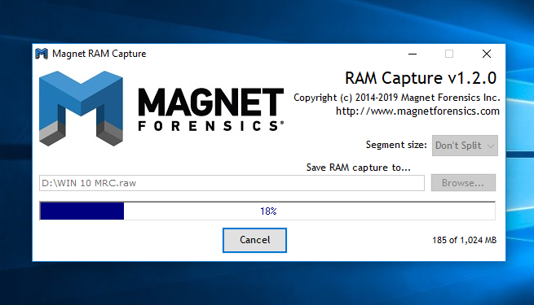

Step 6: the Captured Memory Will Then Be Stored in The Designated Directory Folder

Figure 22

Figure Windows File Explorer Displaying Contents of Local Disk (D:) After Memory Acquisition

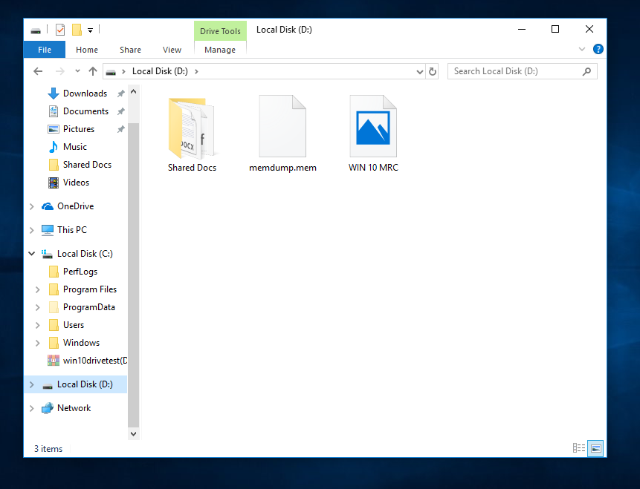

**3.3** Loading MRC Image file into Volatility Workbench V3.0

Step 1: Extract the downloaded Volatility Workbench ZIP file and open the extracted folder.

Figure File Explorer showing Volatility Workbench Zip file and its extracted folder

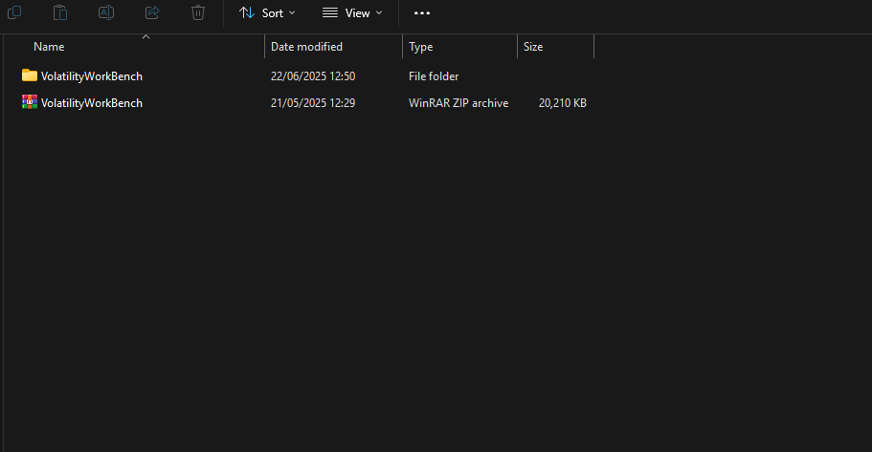

Step 2: Download the MRC image file (KeyLogger.mem) and keep it ready for the Volatility Workbench.

Figure MRC Image File KeyLogger.mem in File Explorer

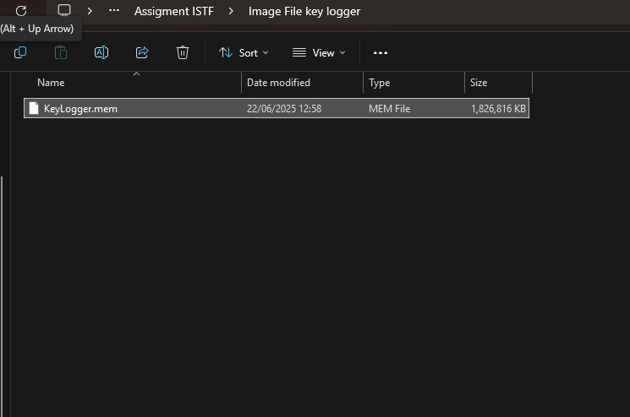

Step 3: Open the extracted folder and click Volatility Workbench to launch the application.

Figure Contents of the Volatility Workbench Extracted folder

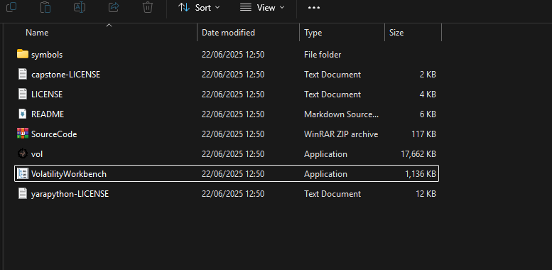

Step 4: Open Volatility Workbench and click Browse Image, then select the KeyLogger.mem file.

Figure Loading the KeyLogger.mem MRC Image file into the Volatility Workbench

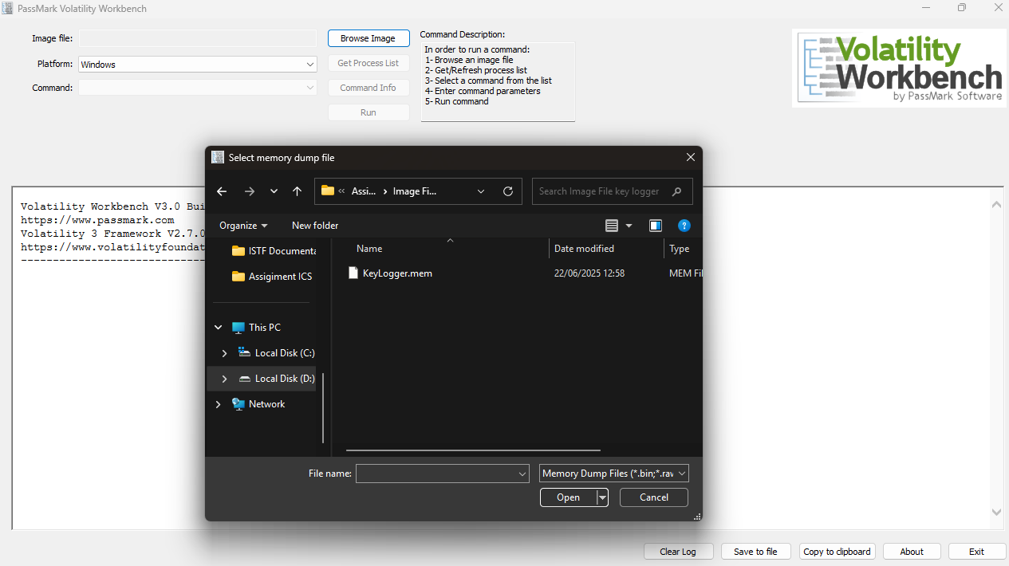

Step 5: After selecting the image file, click Refresh Process List to load and view all running processes.

Figure Volatility Workbench Command Output when Refresh Process List is clicked

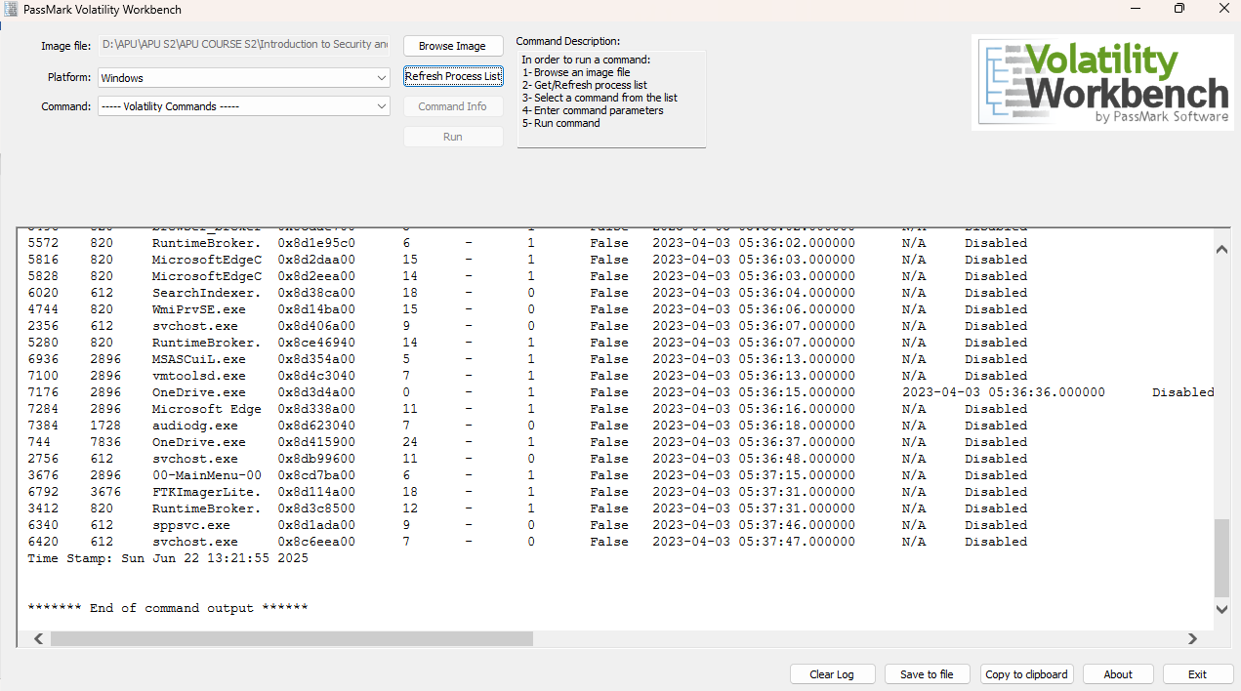

Step 6: Choose (windows.pstree.PsTree) from the command list and click Run to see which processes started other processes.

Figure Displaying contents of Volatility Command windows.pstree.PsTree

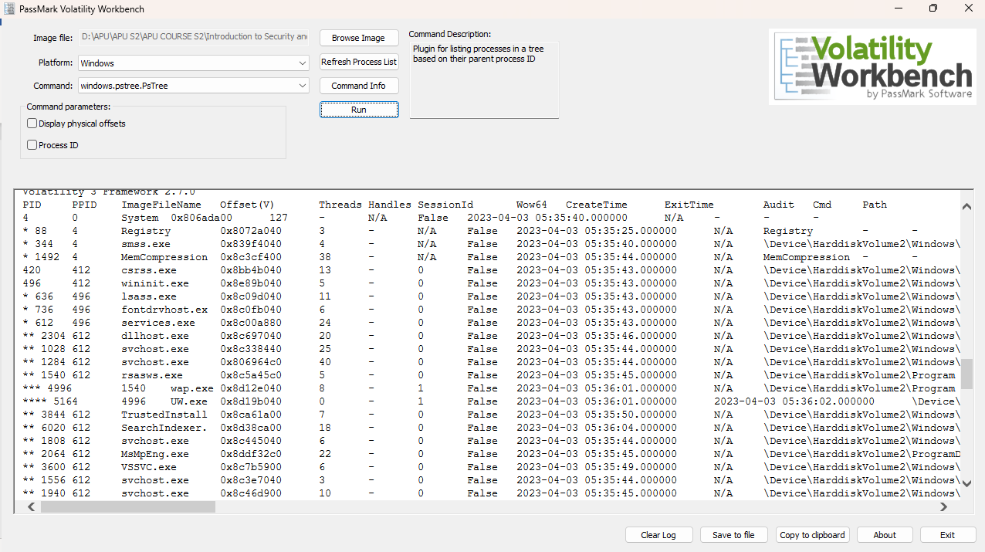

**3.4** New Case Creation and HDD data extraction using Autopsy 4.22.1

Step 1: create a new case

Figure 30 Figure Autopsy 4.22.1 Welcome Screen with Case Options

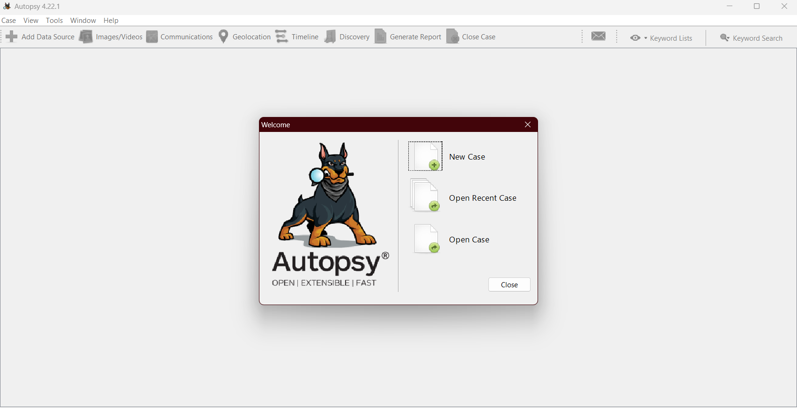

Step 2: enter case name

Figure Autopsy 4.22.1 New Case Information Dialog Box

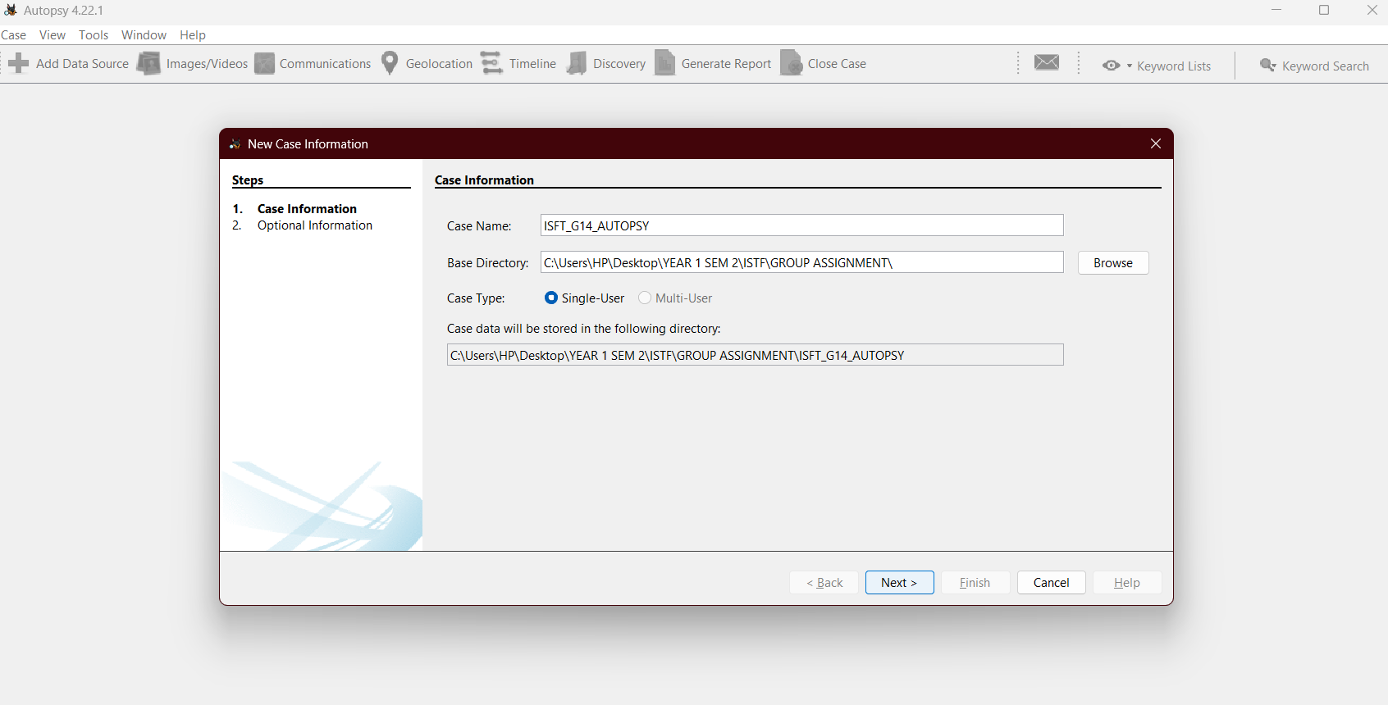

Step 3: confirm case details

Figure Autopsy 4.22.1 Optional Case Information for Examiner Details

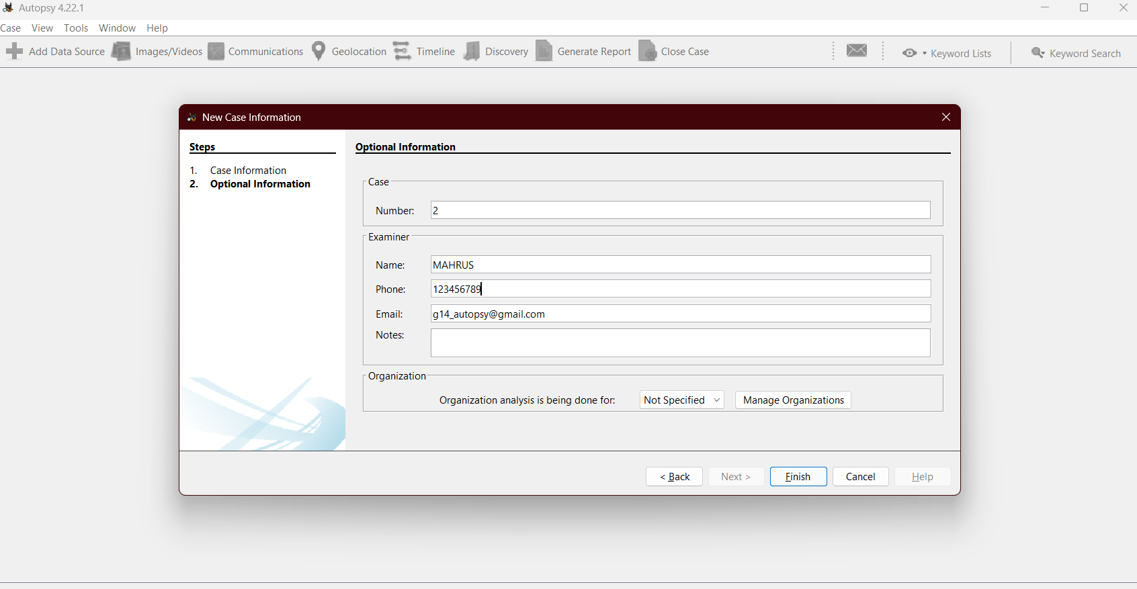

Step 4: select host

Figure Autopsy 4.22.1 "Add Data Source" Wizard for Host Selection

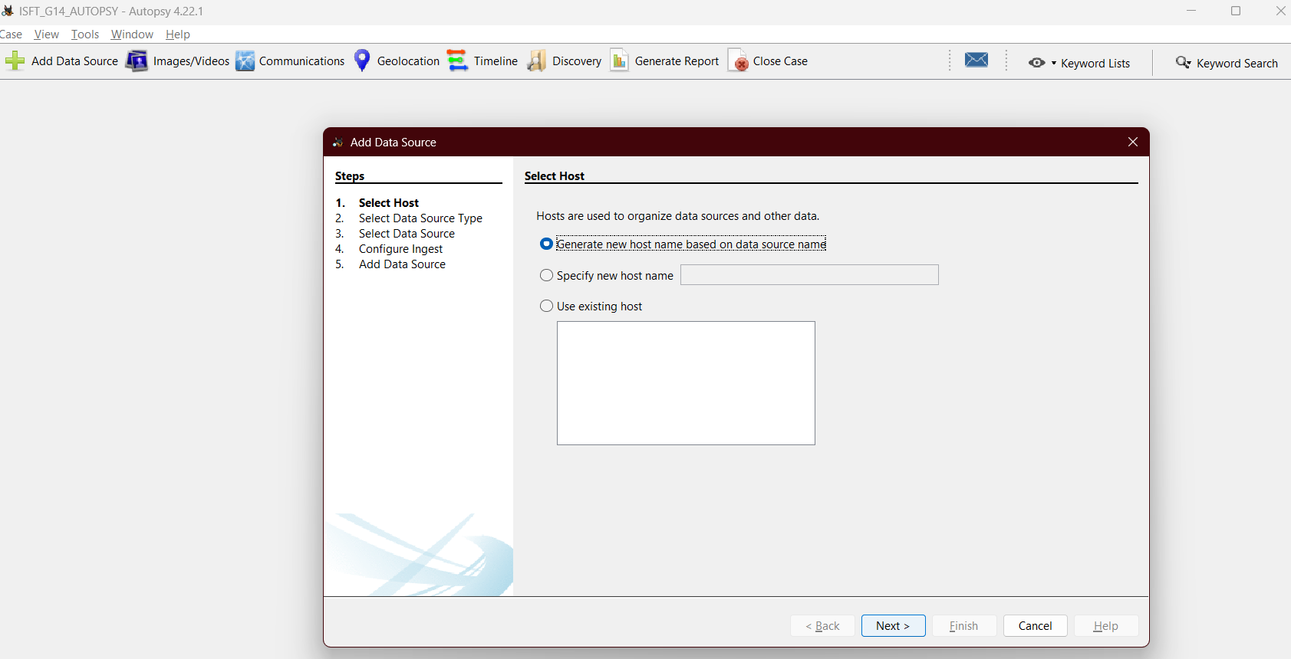

Step 5: In select data source type, select “Disk Image or VM File”

Figure Autopsy 4.22.1 Select Data Source Type Windows Form

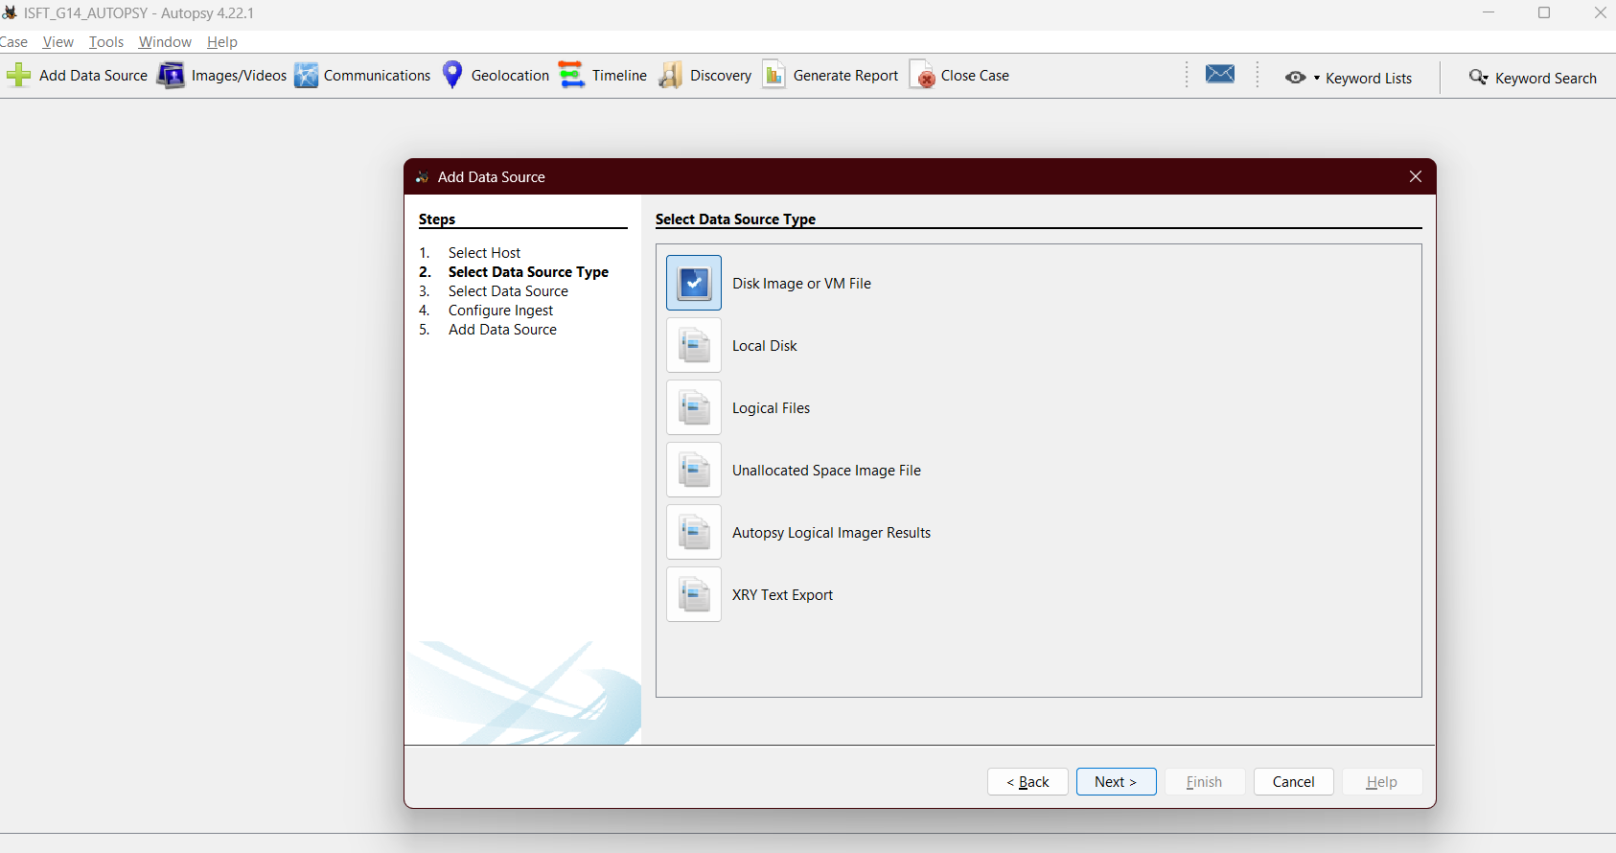

Step 6: select file path. Locate where the Windows 10 (infected) .vmdk file has been downloaded and select it as file path

Figure Figure Autopsy 4.22.1 Select Data Source Windows Form

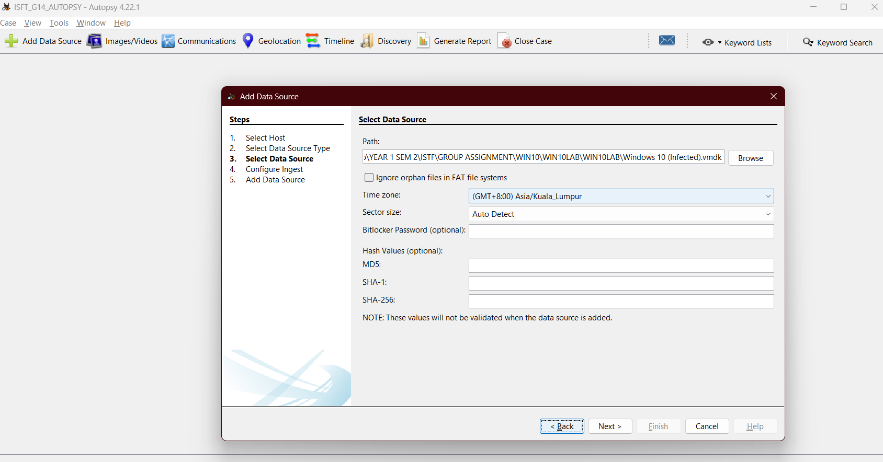

Step 7: configure the ingest

Figure Autopsy 4.22.1 Configure Ingest Windows Form

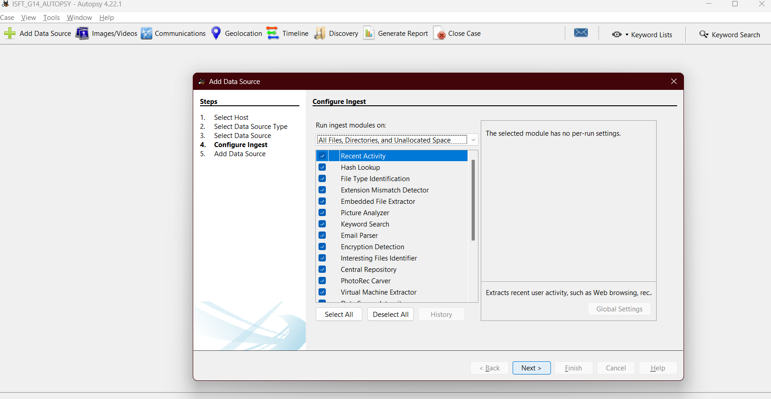

Step 8: add data source. Once selected, wait for the data source to be added to the local database. Then click finish.

Figure Autopsy 4.22.1 Add Data Source Windows Form

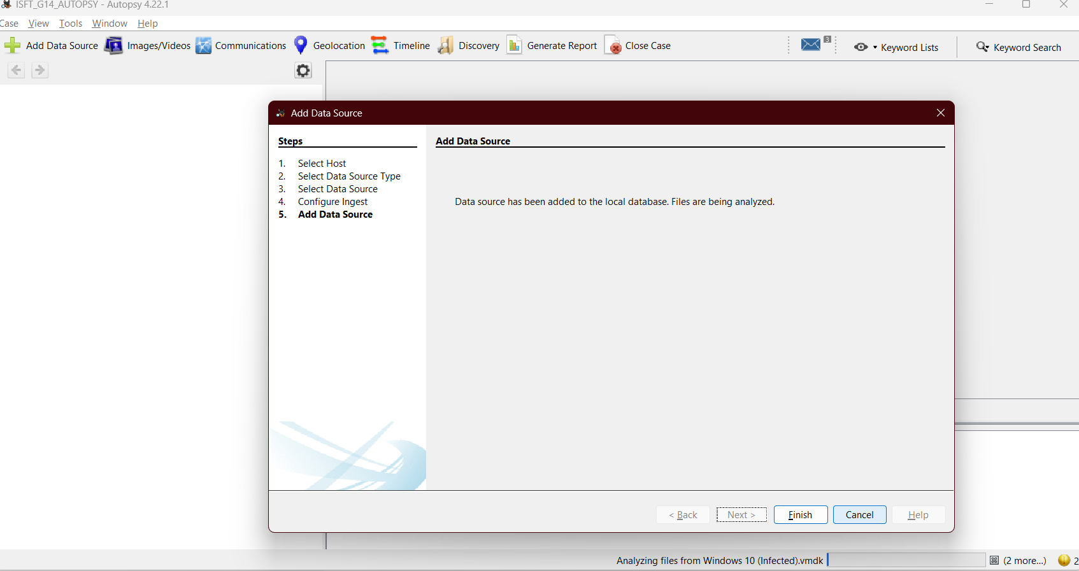

CHAPTER 4: RAM & HDD IMAGE ANALYSIS

**4.1** Ram Analysis using PassMark Volatility Workbench V3.0

**4.1.1** Potential Malware Detections from Command Line Analysis

Analysis of the windows.cmdline.CmdLine plugin output from the Volatility Workbench log file reveals several suspicious processes and activities, suggesting the presence of malware or unauthorized software on the system. The key findings are:

Figure Volatility Workbench windows.cmdline.CmdLine command showing malicious .exe program files

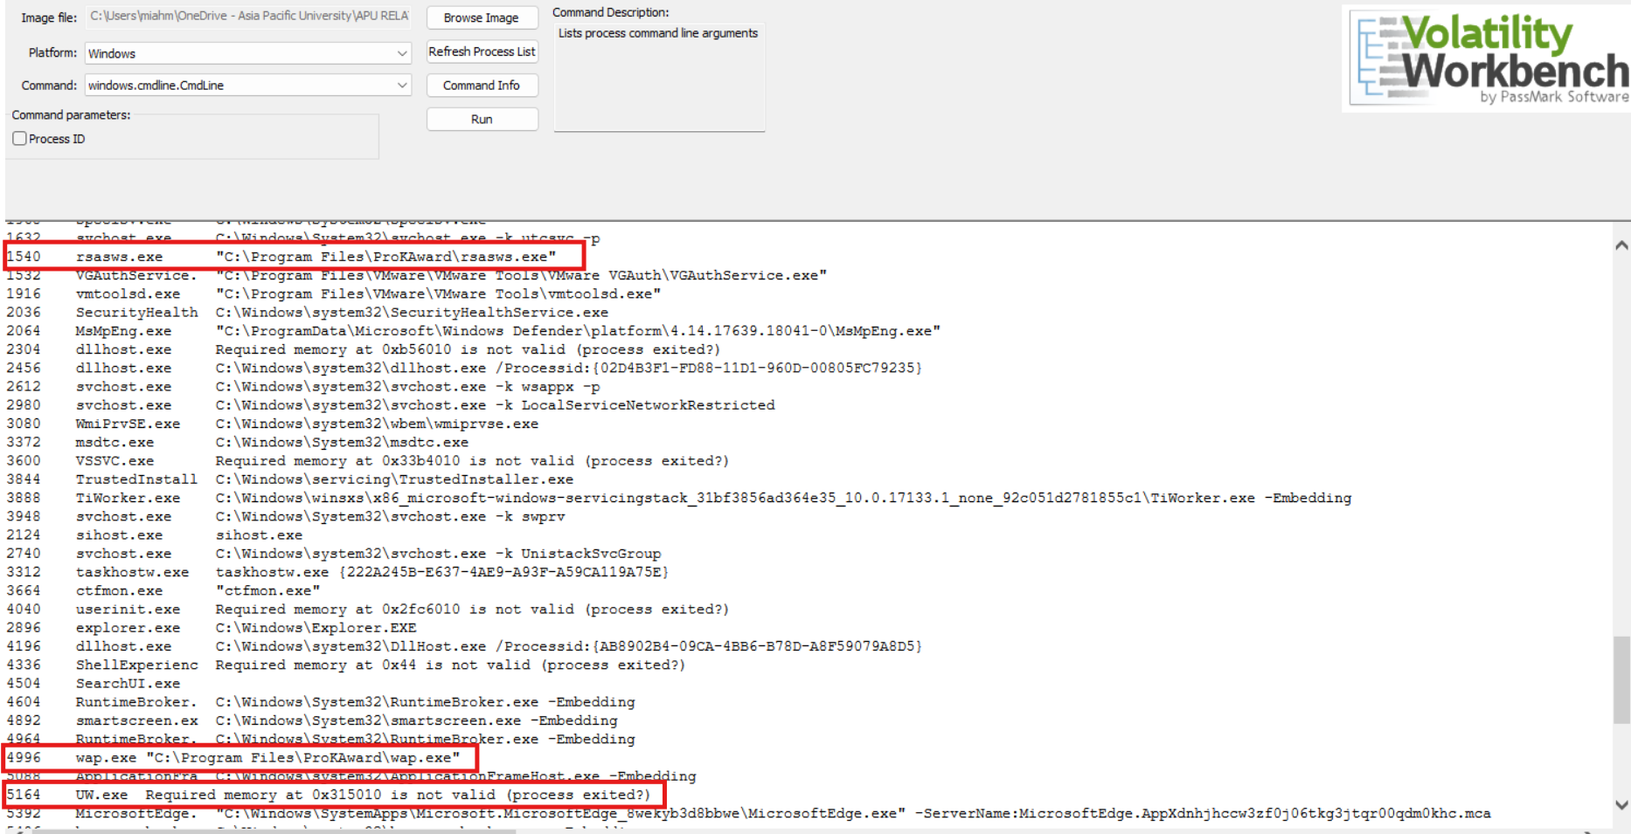

* rsasws.exe (PID 1540): This process is executing from a non-standard path: "C:\Program Files\ProKAward\rsasws.exe". Its parent is services.exe (PID 612).
* wap.exe (PID 4996): This process is also executing from the suspicious ProKAward directory: "C:\Program Files\ProKAward\wap.exe". It is a direct child of rsasws.exe (PID 1540), indicating a direct relationship in the infection chain.
* UW.exe (PID 5164): Although its command line arguments are not fully captured (indicated by "Required memory at 0x315010 is not valid (process exited?)") , its parent process is wap.exe (PID 4996), further linking it to the suspicious ProKAward processes. This suggests UW.exe is likely another component of the same malicious activity.

**4.1.2** Operating System Information from Memory Dump

Figure windows.info.Info Command showing Operating System details

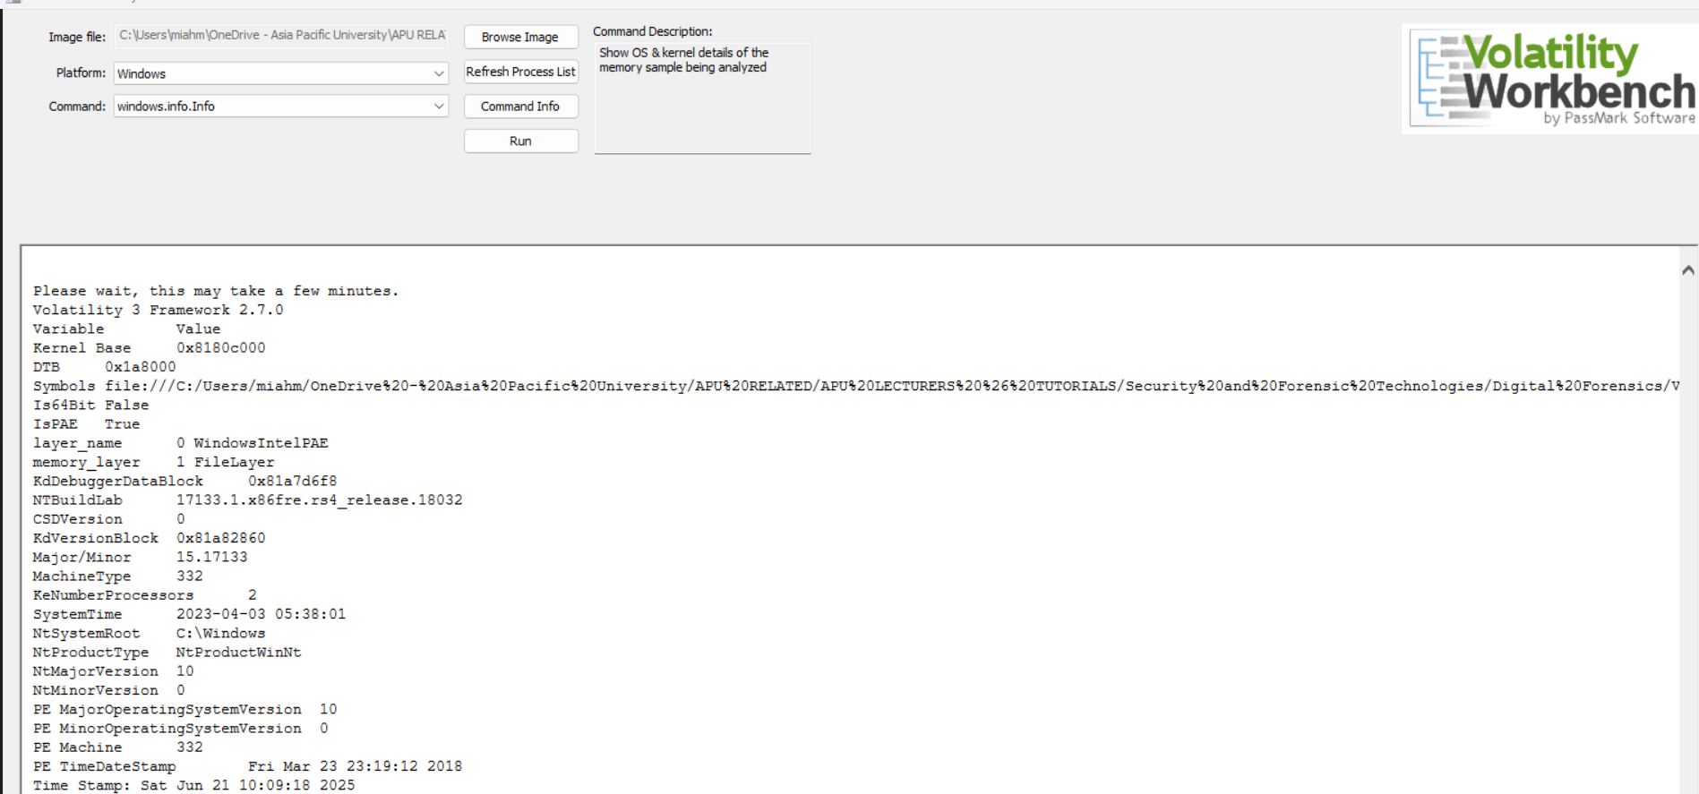

This memory dump was acquired from a 32-bit (x86) Windows 10 system, specifically running Build 17133.1. This build corresponds to the Windows 10 April 2018 Update (version 1803), code-named "Redstone 4".

Key details extracted from the memory image indicate:

* **Operating System**: Microsoft Windows 10
* **Version**: 10.0
* **Build**: 17133.1 (often internally referenced as rs4_release.18032)
* **Architecture**: x886 (32-bit) with Physical Address Extension (PAE) enabled, indicating the system can access more than 4GB of physical memory despite being a 32-bit OS.
* **Number of Processors**: 2
* **System Root**: C:\Windows
* **Dump Acquisition Time**: The memory dump was taken on April 3, 2023, at 05:38:01 UTC.
* **Volatility Analysis Time**: The Volatility analysis was performed on June 21, 2025, at 07:56:45 +08:00 (Malaysia time).

**4.1.3** Malware Analysis via windows.malfind.Malfind

The windows.malfind.Malfind plugin, designed to identify code injection and other suspicious memory regions, has identified several potentially anomalous areas within the memory dump. Notably, no direct evidence of wap.exe (PID 4996), UW.exe (PID 5164), or rsasws.exe (PID 1540) containing malicious code injections was found during targeted scans. This suggests these processes, while potentially part of the investigation's focus, do not exhibit the typical in-memory characteristics of injected or self-modifying malware based on malfind's heuristics.

However, the broader scan of all processes revealed suspicious memory regions in the following executables:

**1. MsMpEng.exe (PID 2064):** Two distinct memory regions within the Windows Defender Antimalware Service Executable were flagged with PAGE_EXECUTE_READWRITE (RWX) protection.

* Region 1: 0x1e030000 to 0x1e12ffff.
* Region 2: 0x1e130000 to 0x1e32ffff. PAGE_EXECUTE_READWRITE permissions are highly suspicious for typically read-only or execute-only code sections of legitimate applications. While MsMpEng.exe is an antivirus program and might legitimately use such permissions for unpacking or scanning, these large RWX regions warrant further investigation to rule out code injection or modification by malware attempting to evade detection by compromising the antivirus itself.

Figure windows.malfind.Malfind findings show MsMpEng.exe having Page_Execute_ReadWrite Permissions

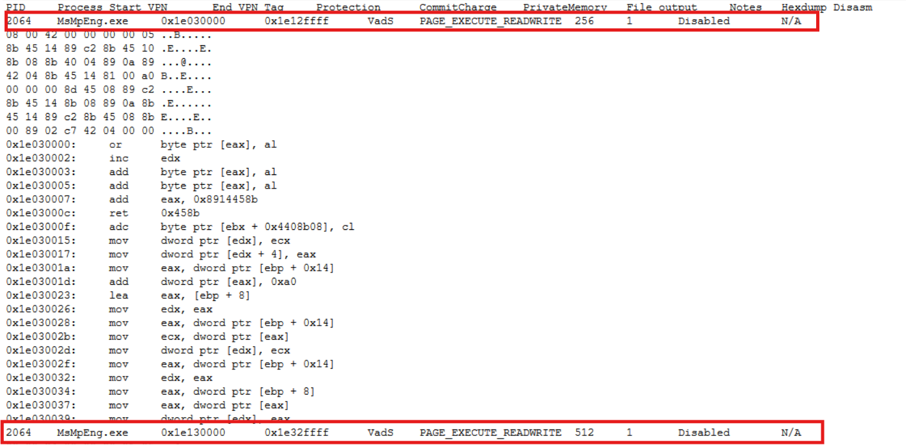

**2. smartscreen.ex (PID 4892):** A memory region from 0x4a40000 to 0x4a5ffff was identified with PAGE_EXECUTE_READWRITE (RWX) protection and noted as containing a "PE header". The presence of a PE header within a dynamically allocated or modified RWX region, especially outside of a normal module load, is a strong indicator of potentially injected or unpacked executable code. This is a critical finding requiring immediate deeper analysis.

Figure windows.malfind.Malfind findings show smartscreen.exe having Page_Execute_ReadWrite Permissions



**3. Microsoft Edge (PID 7284):** A small memory region from 0x1230000 to 0x1230fff also exhibited PAGE_EXECUTE_READWRITE (RWX) protection. Browsers are common targets for exploit kits and code injection, making this finding suspicious.

Figure windows.malfind.Malfind findings show Microsoft Edge having Page_Execute_ReadWrite Permissions



**4. OneDrive.exe (PID 744):** A memory region from 0x62e0000 to 0x62effff was found with PAGE_EXECUTE_READWRITE (RWX) protection. Like browser processes, cloud synchronization clients can be targeted.

Figure windows.malfind.Malfind findings show OneDrive.exe having Page_Execute_ReadWrite Permissions



**4.1.4** User Session Information for rsasws.exe and wap.exe

Figure Windows.sessions.Sessions Command showing Session IDs of rsasws.exe and wap.exe

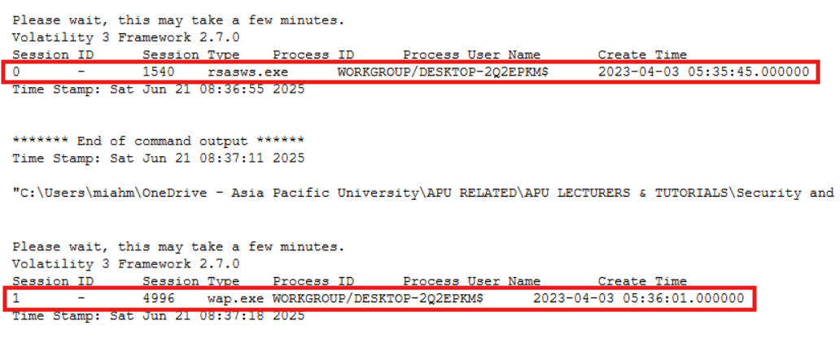

The Volatility 3 windows.sessions.Sessions plugin was used to gather user session information related to the rsasws.exe and wap.exe processes from the memory dump. The session information provides crucial context for understanding the execution environment of rsasws.exe and wap.exe.

* rsasws.exe **running in Session 0** suggests it likely operates as a system service or a background process that does not require direct user interaction. Its presence and activity should be evaluated against its known legitimate functions to determine if its behavior is consistent with normal system operation or indicative of unauthorized activity.
* wap.exe running in Session 1 confirms it was executed within an interactive user session. This is an important distinction, as malware often runs in user sessions to interact with the desktop, capture user input like keystrokes, or access user-specific files. The fact that wap.exe was running under the interactive user WORKGROUP/DESKTOP-2Q2EPKM$ at 05:36:01 on April 3, 2023, is highly relevant for correlating its activity with potential user actions or compromise events at that specific time.

**4.1.5** Analysing Open Handles of wap.exe and rsasws.exe

Figure shows windows.handles.Handles command run output of wap.exe

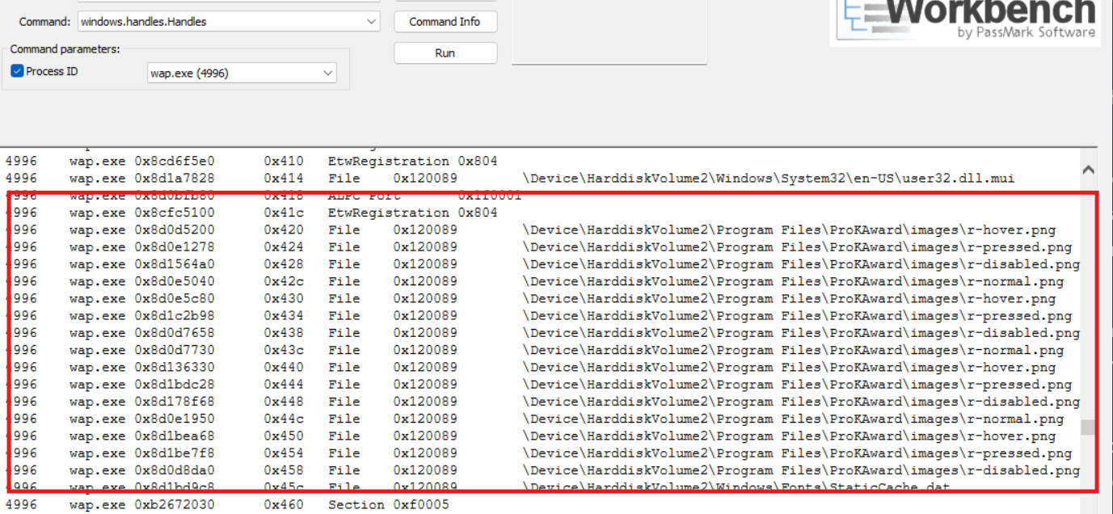

The windows.handles.Handles command run output for wap.exe showed interaction with files in the \Program Files\ProKAward\images\ directory which was noted as a strong indicator of a keylogger.

Figure shows windows.handles.Handles command run output of rsasws.exe

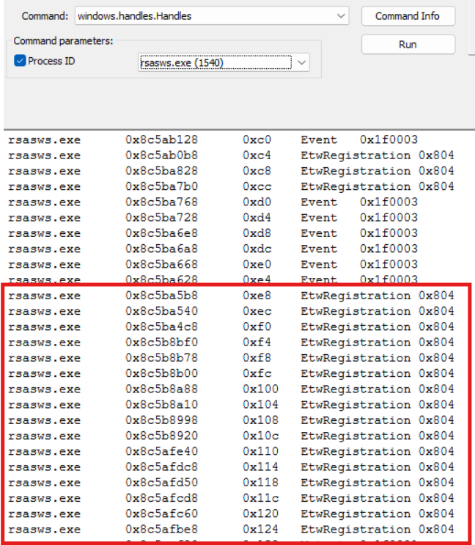

A very high number of EtwRegistration handles are observed. This indicates that rsasws.exe is extensively registering for Event Tracing for Windows (ETW) events. ETW is a powerful logging mechanism used by legitimate applications and by malware for reconnaissance or monitoring system activities.

Critically, rsasws.exe has an open handle to wap.exe (PID 4996). This indicates a direct relationship where rsasws.exe is monitoring, controlling, or communicating with wap.exe.

**4.1.6** Analysing Security Identifiers(SIDs) of wap.exe and rsaws.exe

Figure windows.getsids.GetSIDs command run shows user privileges of wap.exe and rsasws.exe

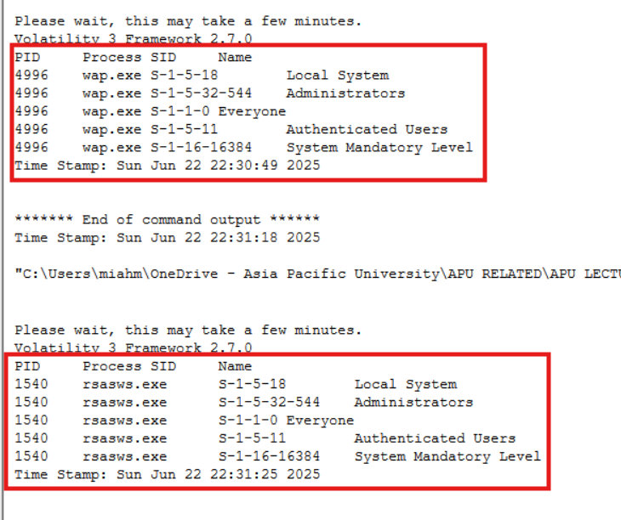

Both wap.exe (PID 4996) and rsasws.exe (PID 1540) exhibit identical, highly privileged user contexts. Each process is associated with:

* **S-1-5-18 (Local System):** Granting ultimate control over the local machine, typically reserved for OS services.
* **S-1-5-32-544 (Administrators):** Confirming administrative capabilities.
* **S-1-1-0 (Everyone) & S-1-5-11 (Authenticated Users):** Indicating broad user access.
* **S-1-16-16384 (System Mandatory Level):** Assigning the highest integrity level, making them resilient to termination or modification by lower-privileged processes.

The windows.getsids.GetSIDs command run confirms that both rsasws.exe (PID 1540) and wap.exe (PID 4996) are active keylogger trojans operating with catastrophic system-level privileges. Identical Security Identifiers for both processes indicate a severe, coordinated compromise enabling comprehensive keystroke logging, complete system control, and extreme resistance to removal due to their System Mandatory Level integrity. This situation allows for extensive data theft, potential deployment of further malicious payloads, and significant risk of lateral movement. Immediate and drastic containment and remediation measures are imperative.

**4.2** HDD Analysis using Autopsy 4.22.1

**4.2.1** wap.exe

wap.exe is a rogue executable that is reported to be a keylogger which falls in both PUA (Potentially Unwanted Application) and Trojan types. It was found in the ProKAward folder within the Program Files, and it is thus possible that it was an installation of advanced bundle or disguise application. Based on behaviour analysis and anti-virus findings, there is a high possibility of monitoring devices, capturing of keystroke and persistence type of mechanisms. **43 of 72 antivirus engines have reported this malicious.**

*Figure 50 wap.exe found in Autopsy*

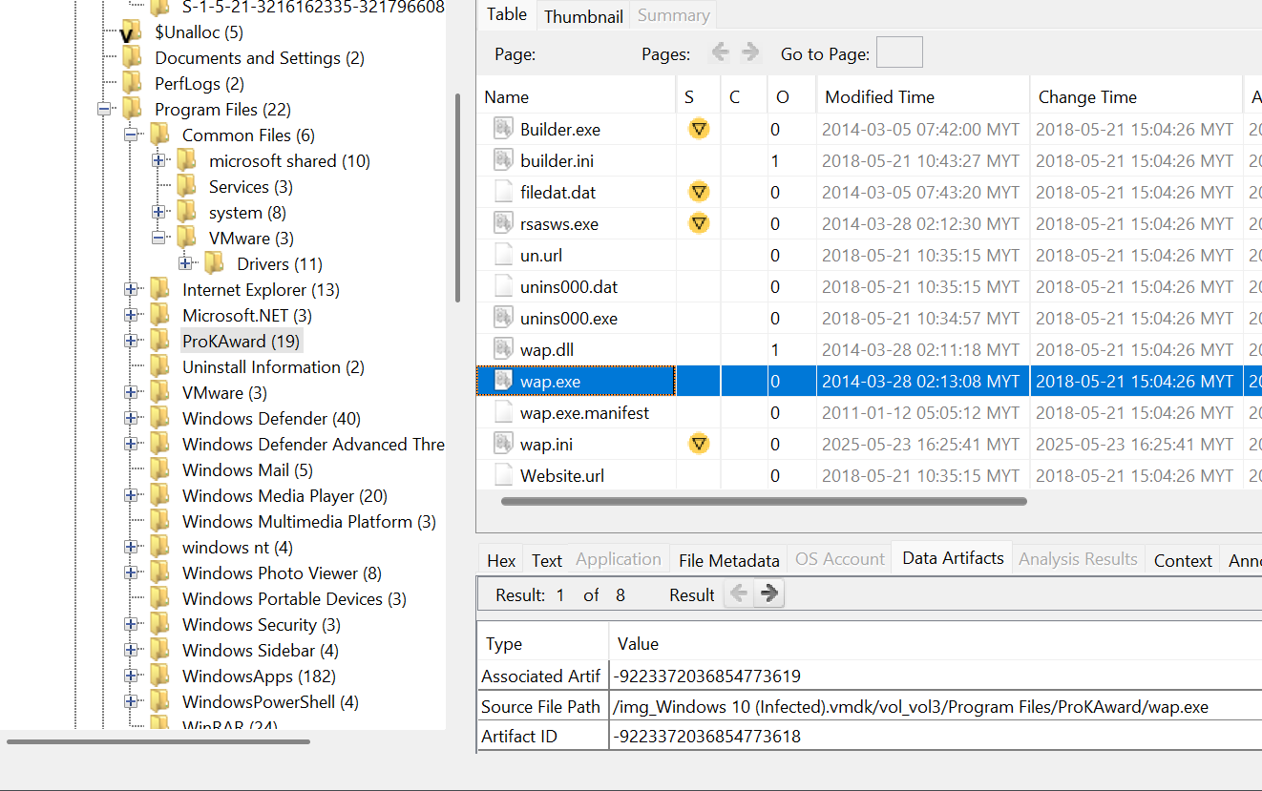

*Figure 51 wap.exe flagged as malicious file on VirusTotal*

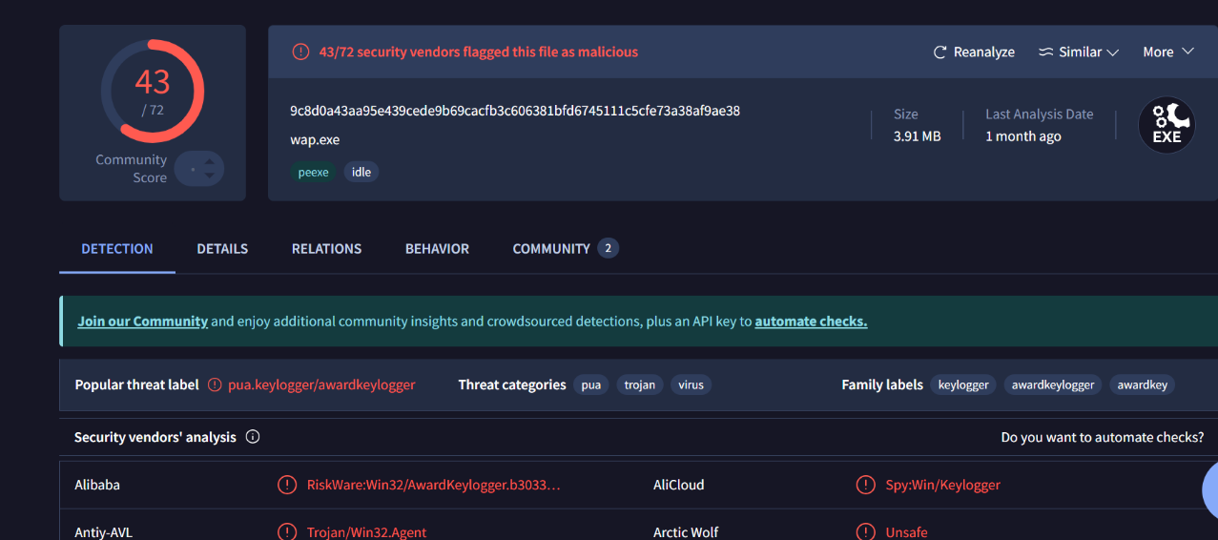

**4.2.2** rsaws.exe

rsasws.exe is a dangerous program described as an AwardKeylogger family member. It was detected in the ProKAward program directory, and it is marked as a Trojan and PUA (Potentially Unwanted Application). The file shows some anti-debugging and disk space searches and timing delays (long sleeps) to evade detection typical to monitoring software. VirusTotal reports the file as malicious, **with 36 out of 72**, usually marked as trojan.awardkeylogger/monitor.

*Figure 52 rsaws.exe found in Autopsy*

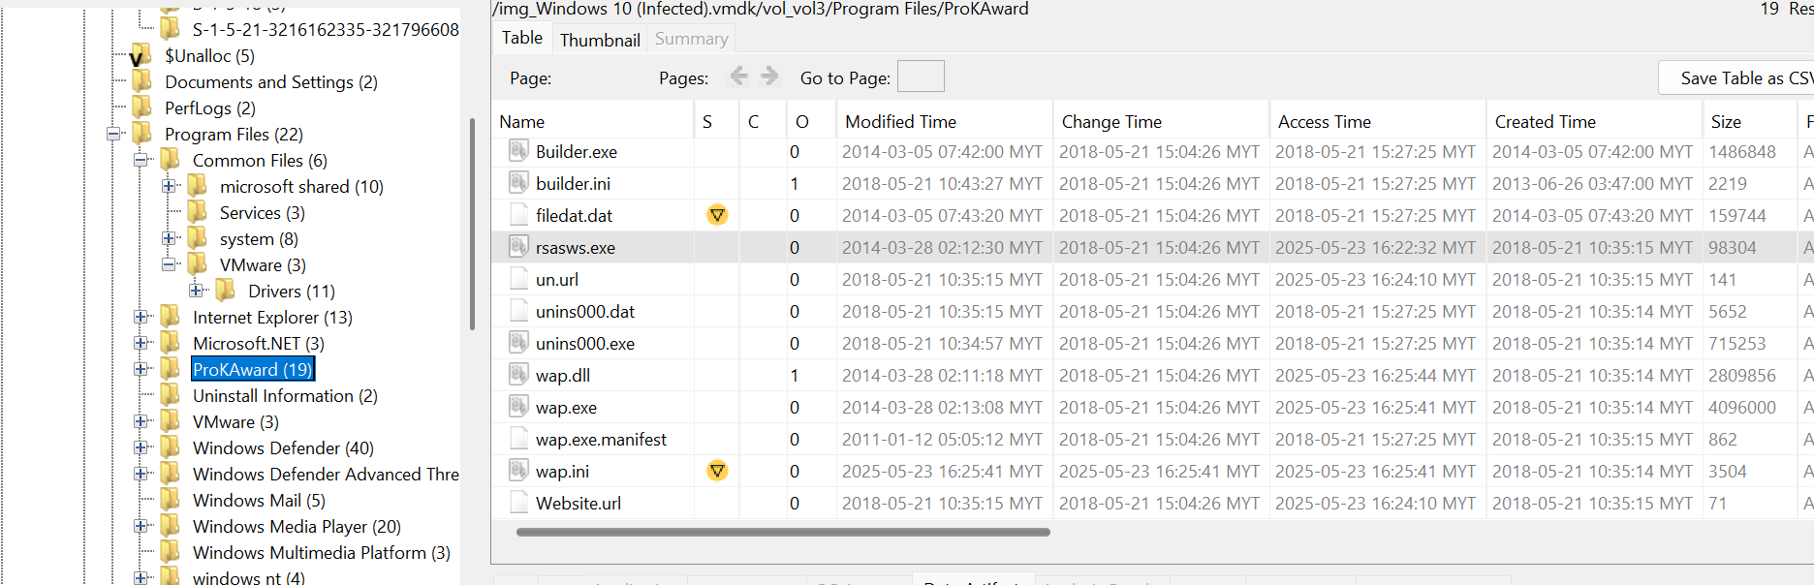

*Figure 53 rsasws.exe flagged as malicious file on VirusTotal*

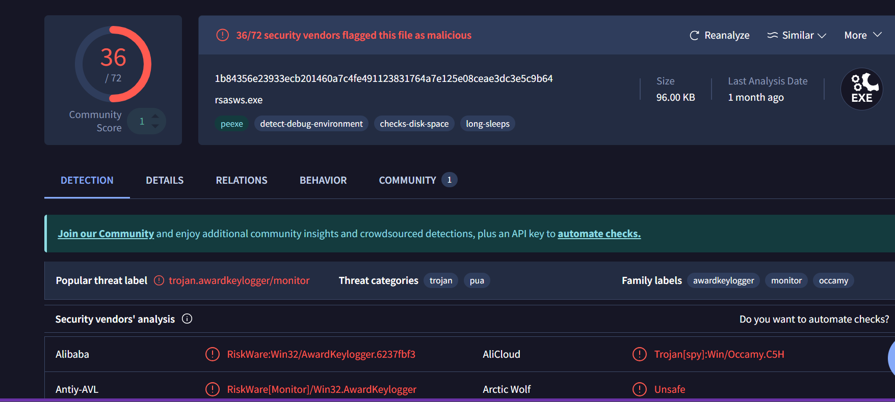

**4.2.3** FakeClient.exe

FakeClient.exe is a suspicious executable file, found in KMSAutoS/bin/driverx86WDV, which usually refers to software cracks or counterfeited activators. Despite the alert manifested by **12/72 antivirus engines**, the file possesses alarming characteristics like an invalid digital signature, direct access to CPU, an indication of overlay signing of the file signalizing potential tampering or obfuscation. It has a possible stealth component as the filename and path are an attempt to circumvent software licenses or detectors.

*Figure 54 FakeClient.exe found in Autopsy*

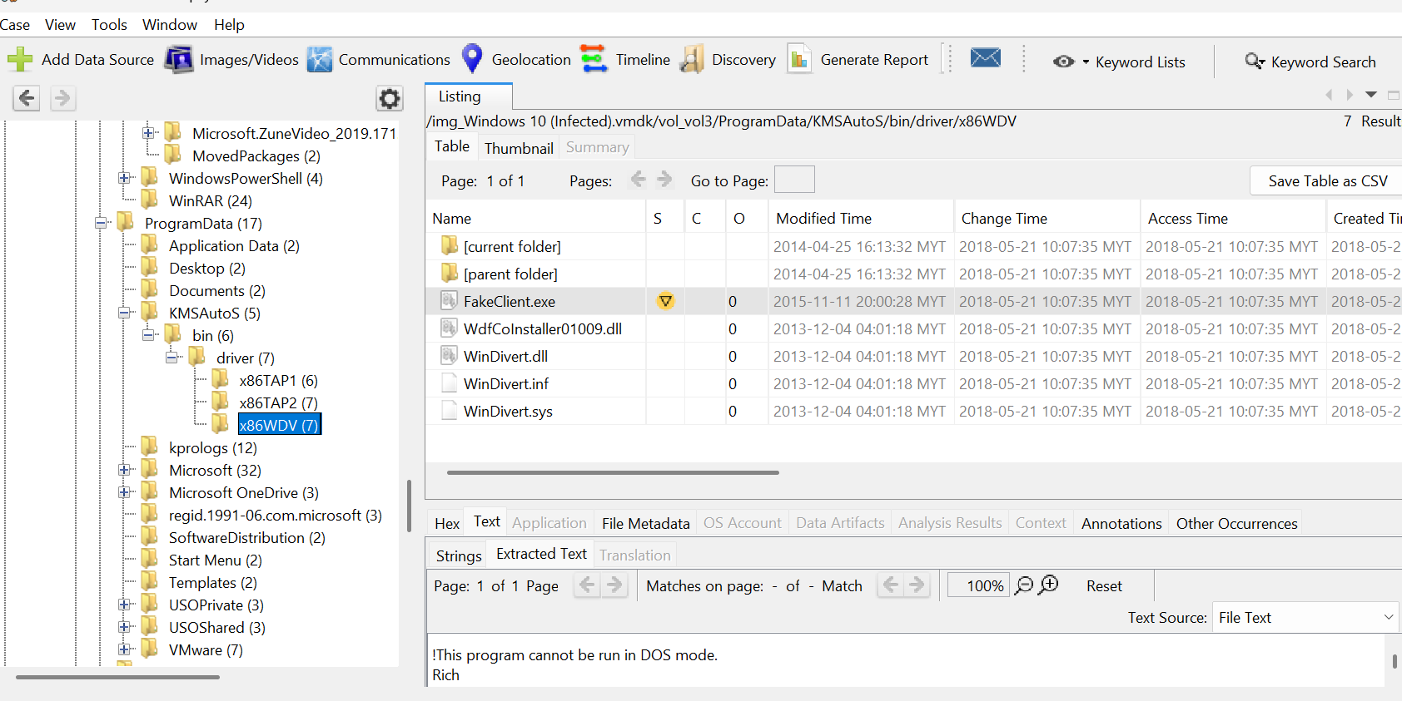

*Figure 55 FakeClient.exe flagged as malicious file on VirusTotal*

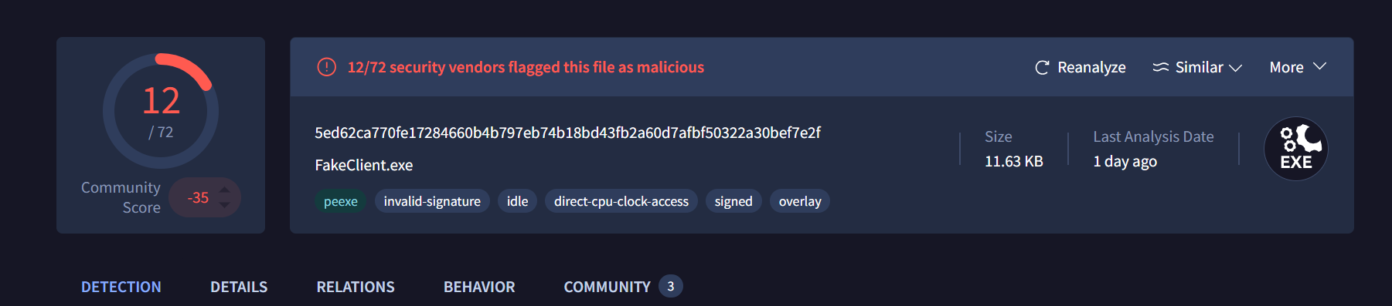

**4.2.4** TunMirror.exe

TunMirror.exe is another malicious executable folder that is found in ProgramData/KMSAutoS/bin, and it is linked with unwarranted changes made to system and suspicious run times activities. **37 out of the 71 antivirus engines** have flagged it as malicious. Signs are invalid signature, use of assembly level manipulation, excessive execution delays and anti-debugging features. The file also tests user interactions, disk space availability, which is an indication that it could be deployed to perform evasion or command other payloads.

*Figure 56 TunMirror.exe found in Autopsy*

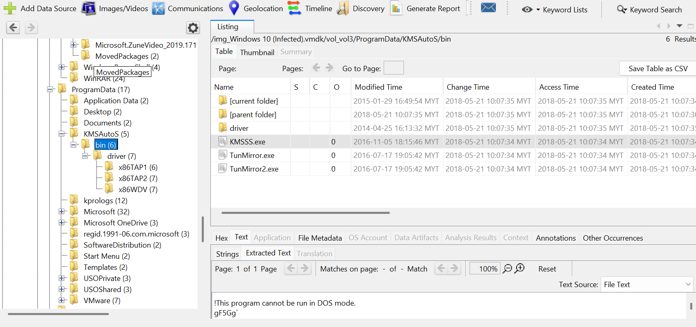

*Figure 57 TunMirror.exe flagged as malicious file on VirusTotal*

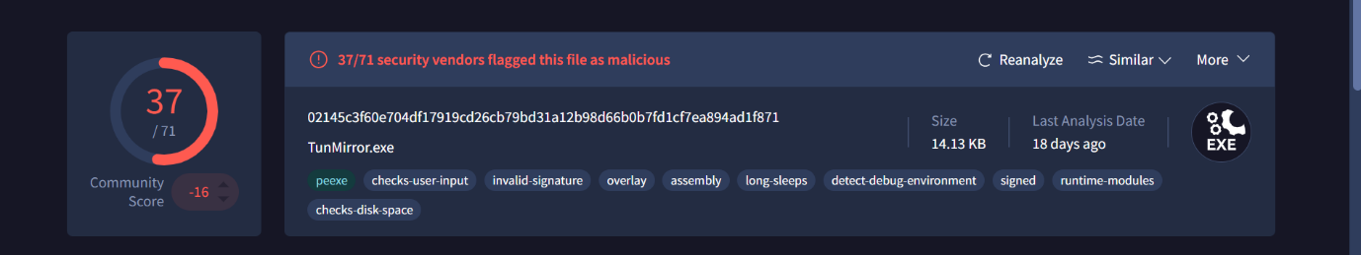

**4.2.5** KMSAuto Net.exe

The common offender of activation-cracking is KMSAuto Net.exe which is also identified as malware by **48 out of 72 antivirus-scanners**. Even though it is commonly deployed as a way to circumvent software licensing, it features malware-like behaviours, such as invalid digital signature, anti-debugging support, the runtime modules, long sleeps and direct access to the CPU. It has been also connected which attempts to exploit CVE-2012-0158 and possible Tor type network Access. This file was found on the Downloads folder of a user and it was located in the KMSAuto.Net.2016.v1.5.0 subfolder.

*Figure 58 KMSAuto Net.exe found in Autopsy*

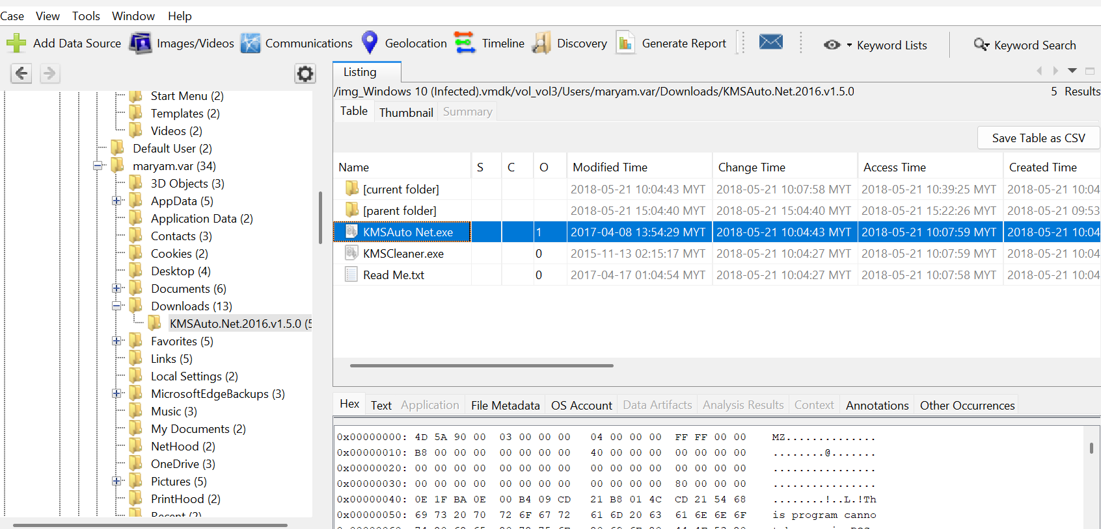

*Figure 59 KMSAuto Net.exe flagged as malicious file on VirusTotal*

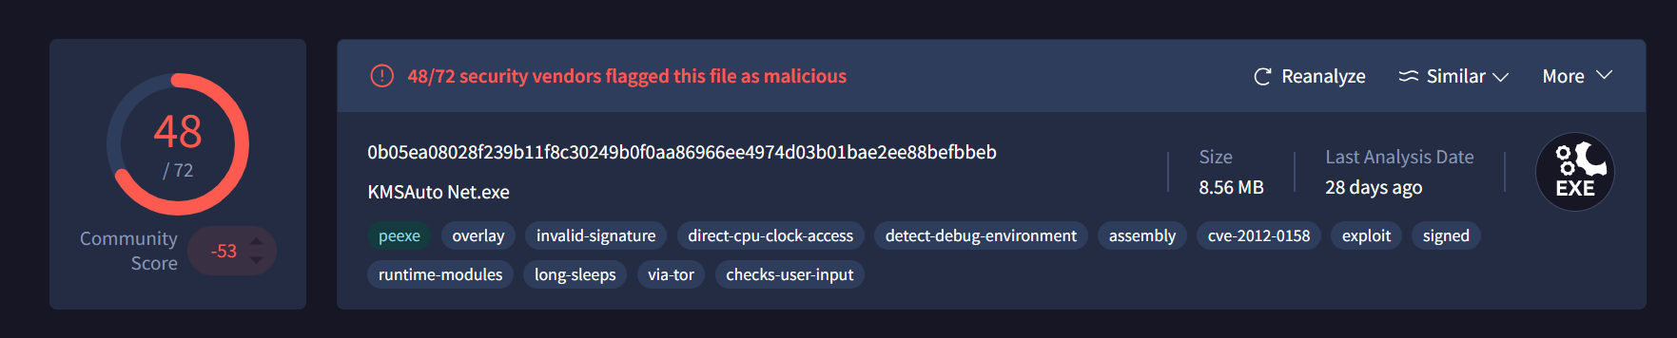

**4.2.6** DLLInjector v2.exe

DLLInjector v2.exe is a possible malicious DLL injection software which can inject a code in a hidden way into other processes, a typical trick within the malware implementation and avoidance. It was discovered in the Downloads folder and has properties, e.g. anti-debugging, network adapters enumeration, and module execution run time. Analysis reveals that **41 of the 72 antivirus engines** detected the executable as malicious, thus it might be highly unlikely to use this executable in post-exploitation operations.

*Figure 60 DLLInjector v2.exe found in Autopsy*

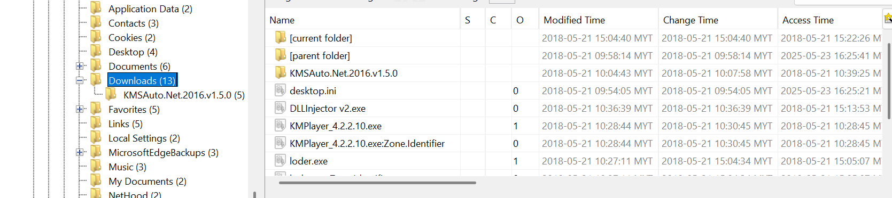

*Figure 61 DLLInjector.exe flagged as malicious file on VirusTotal*

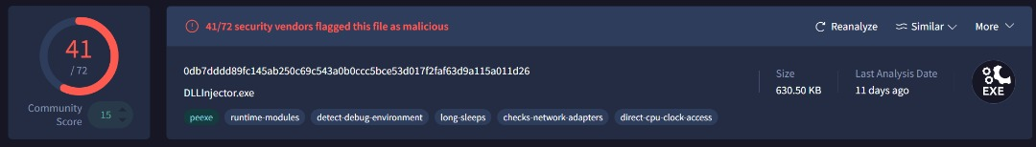

Note : When the hash code of "DLLInjector v2.exe" found in Autopsy was searched on VirusTotal, the results displayed "DLLInjector.exe" as the file name, not "DLLInjector v2.exe".

**4.2.7** updsto.exe

Updsto.exe is a malicious executable file and it is identified as a Trojan from the Ursu malware family, packed with Themida to evade detection. It was found in the user’s Download folder and has string behavioural of malware (e.g., direct CPU clock access and WMI calls), VirusTotal analysis shows it was flagged as malicious **by 61 out of 72 antivirus engines.**

*Figure 62 upsdto.exe found in Autopsy*

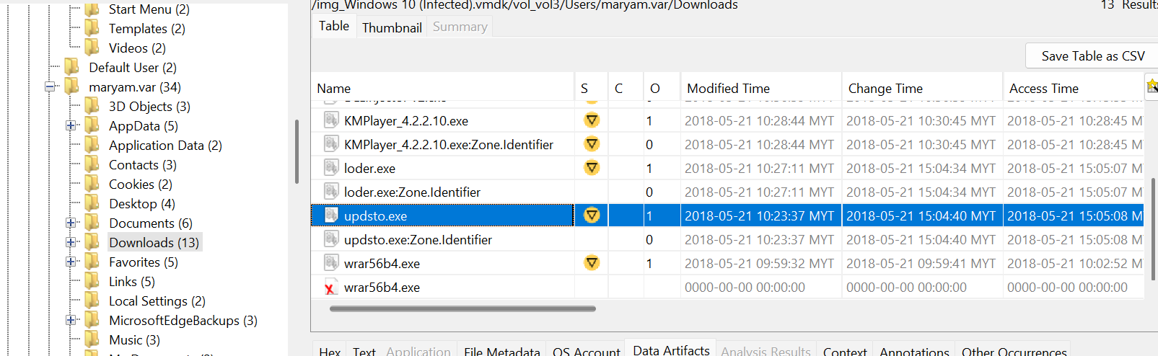

*Figure 63 SpNativeMessage.exe flagged as malicious file on VirusTotal*

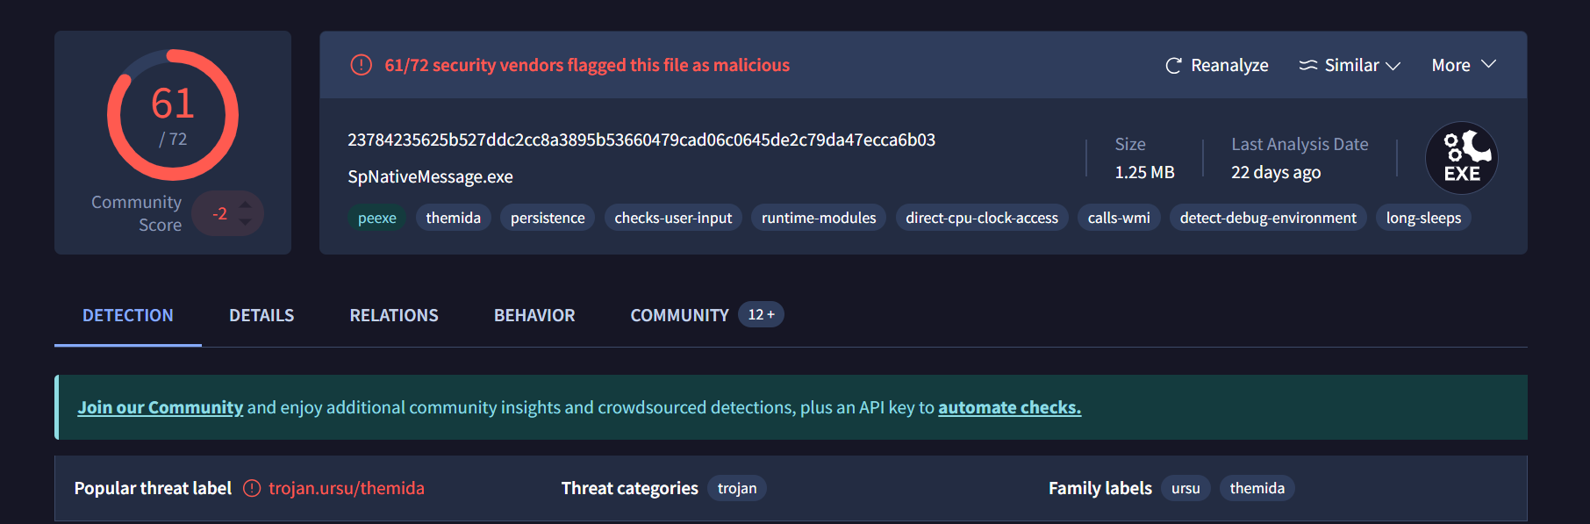

Note : When the hash code of "updsto.exe" found in Autopsy was searched on VirusTotal, the results displayed "SpNativeMessage.exe" as the file name, not "updsto.exe".

**4.2.8** KMSCleaner.exe

KMSCleaner.exe is a malicious tool with the name in the Downloads\ KMSAuto.Net.2016.v1.5.0 directory that is likely to be cleaned-up or deactivated KMS-based license activation tools. The antivirus engines have **26 out of 49 flagging** it as malicious. Behavioural signs are an ineffective digital signature, the ability to directly access CPU, activity related to Tor, and anti-debugging actions. Albeit its name suggests a clean-up role, its actions indicate it could have a second, covert role.

*Figure 64 KMSCleaner.exe found in Autopsy*

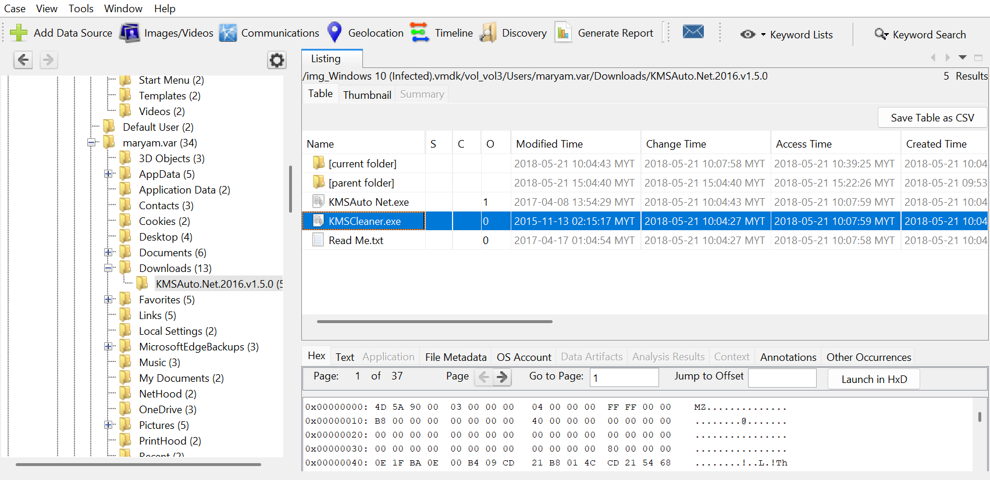

*Figure 65 14240-KMSCleaner.exe flagged as malicious file on VirusTotal*

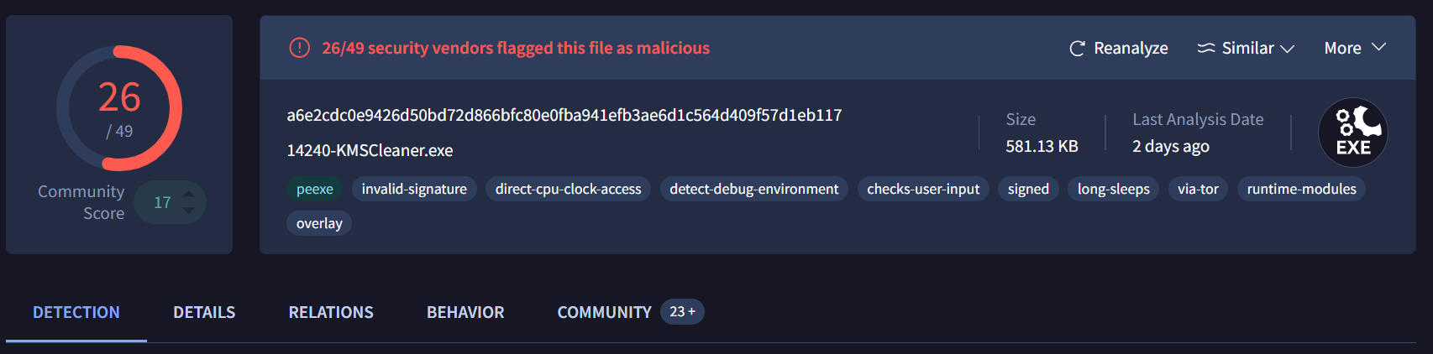

**4.2.9** KMSSS.exe

KMSSS.exe is a suspicious executable file located in the ProgramData\KMSAutoS\bin folder and closely associated with unauthorized license activation tools such as KMSAuto. According to malware analysis results, **38 out of 70 antivirus engines** classified this file as malicious, indicating a high-risk level. While its name suggests a connection to common activation bypass tools, its behavioural indicators suggest a more complex function. These indicators include the use of invalid digital signatures, abnormal sleep cycles (long periods of sleep), direct access to the CPU clock, and the detection of debugging environments—techniques commonly used to evade analysis and detection.

The file is relatively small (34.67 KB) and was last modified in 2016. However, it was accessed and modified again in 2018, suggesting it may have originated from an inactive or reactivated toolkit. The presence of other executable files, such as "TunMirror.exe," in the same folder reinforces suspicions that this folder houses components of a larger, more covert operation. Although it appears to be part of a license management tool, the capabilities of KMSSS.exe suggest it may play a secondary, covert role beyond its primary activation bypass function.

*Figure 66 KMSSS.exe found in Autopsy*

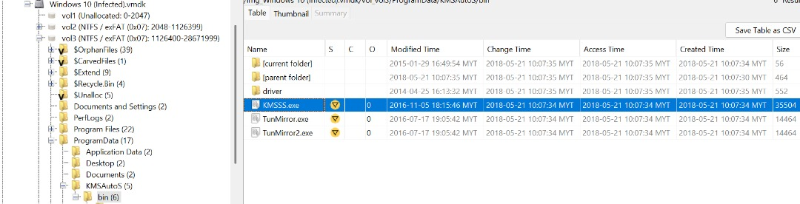

*Figure 67 KMSSS.exe flagged as malicious file on VirusTotal*

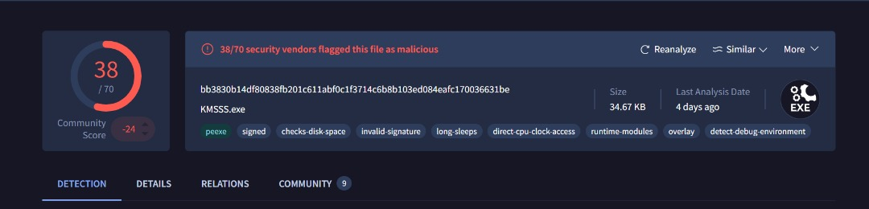

**4.2.10** Ioder.exe

Ioder.exe is a highly suspicious executable file, classified as malicious by **57 out of 72 antivirus vendors** and classified as a data-stealing and data-harvesting Trojan. It was analysed only two hours ago, indicating recent activity. Behavioural signs include persistence mechanisms, patch environment detection, and the use of bundling, all characteristics of malware designed to evade analysis and maintain system access. The file is also classified into several families, such as MSIL/Wacatac and MSIL/Stealer, indicating potential credential theft and data exfiltration.

This executable was found in the user's Downloads folder under the name "loder.exe," consistent with its ambiguous purpose. The file was last modified and accessed in May 2018, and its size is relatively large (approximately 493 KB), suggesting that it could contain complex payloads or be part of a bundled data carrier. Its presence alongside other suspicious executables such as DLLInjector v2.exe, updscto.exe, and war56b4.exe suggests that it could be part of a larger attack set.

*Figure 68 Ioder.exe found in Autopsy*

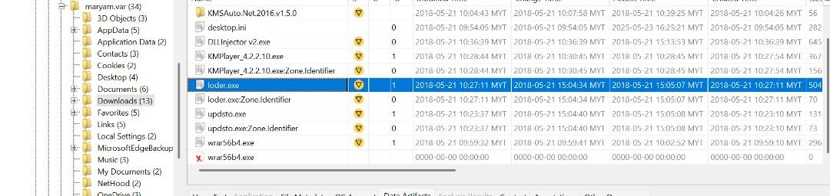

*Figure 69 RtlUpd.exe flagged as malicious file on VirusTotal*

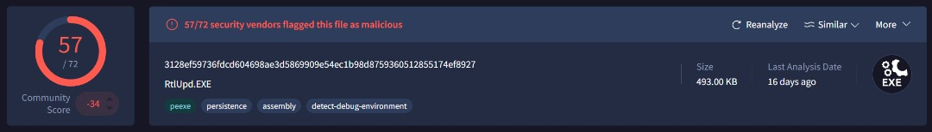

Note: when the hash code of "Ioder.exe" found in Autopsy was searched on VirusTotal, the results displayed "RtlUpd.EXE" as the file name, not "Ioder.exe".

**4.2.11** win10drivetest(Demo).exe

win10drivetest(Demo).exe is a suspicious executable file located in a ZIP archive in the win10drivetest(Demo).zip folder. It has been classified as malicious by **59 out of 72 antivirus programs**, raising serious concerns about its legitimacy. While its name suggests it may be a diagnostic or driver testing tool, its behavioural indicators suggest otherwise. Detected features include user input analysis and the use of overlays, two common techniques used by stealth malware to monitor or deceive users.

With a file size of 158 KB and no record of access or creation times in the file system, metadata suggests attempts at timestamp obfuscation, a deceptive tactic used to disguise file activity or its source. The file was last modified in 2018; However, no other temporal metadata is available, which reinforces its stealth potential. Although the name and packaging suggest a benign utility, its distinctive behaviours and high antivirus detection rate suggest that win10drivetest(Demo).exe may play a hidden malicious role that goes beyond any legitimate system testing function.

*Figure 70 win10drivetest(Demo).exe found in Autopsy*

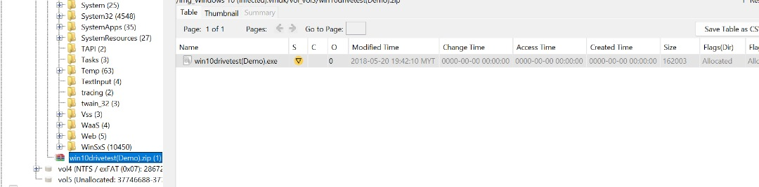

*Figure 71 218841-win10drivetest(Demo).exe flagged as malicious file on VirusTotal*

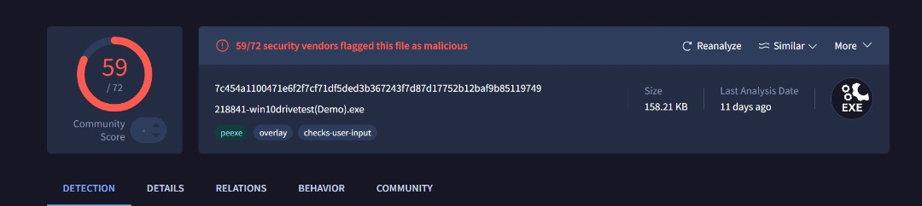

Note: when the hash code of "win10drivetest(Demo).exe" found in Autopsy was searched on VirusTotal, the results displayed "218841-win10drivetest(Demo).exe " as the file name, not "win10drivetest(Demo).exe".

**4.2.12** filedat.dat

The filedat.dat file is a highly suspicious file located in the Program Files\WinRAR folder, masked by a .dat extension to appear as a non-executable data file. Despite this misleading name, **60 out of 72 antivirus engines** classified it as malicious. Behavioural analysis shows that the file exhibits typical malware characteristics, such as maintaining a dormant state to avoid potential detection and delaying its activation until certain conditions are met.

The file, approximately 156 kilobytes in size, was initially modified in 2014. However, it was accessed and modified again in 2018, suggesting its continued presence on the system, possibly within an inactive or hidden payload. Its placement alongside other suspicious executables, such as Builder.exe and rsaws.exe, and several installer-related files, supports the hypothesis that it is part of a larger, more discreet software package. The unusual use of the .dat extension, combined with its ability to detect malware and its inactive behavioural signature, suggests that 15570-filedat.dat was likely designed to hide its true function as a malicious executable embedded in the system under the guise of legitimate application data.

*Figure 72 filedat.dat found in Autopsy*

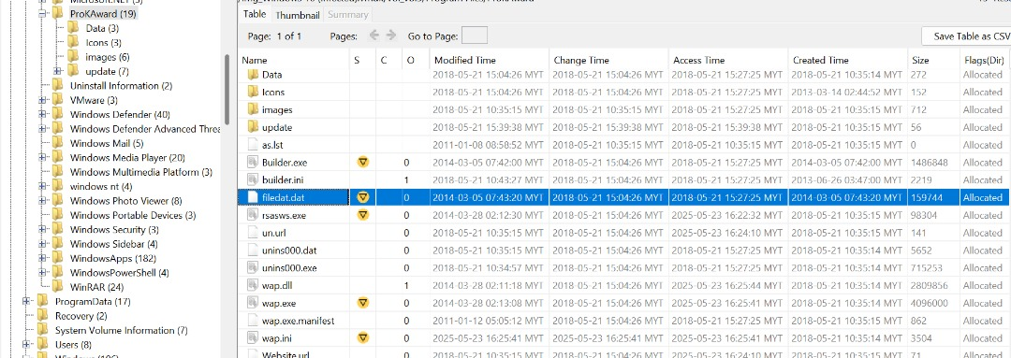

*Figure 73 15570-filedat.dat flagged as malicious file on VirusTotal*

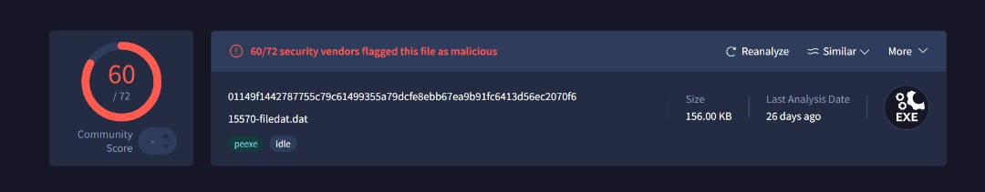

Note: when the hash code of "filedat.dat" found in Autopsy was searched on VirusTotal, the results displayed "15570-filedat.dat" as the file name, not " filedat.dat".

**4.2.13** Final_Test.pdf

The Final_Test.pdf file was found to be a treacherous and deeply suspicious executable during the forensic investigation into an infected Windows 10 system. Despite its use of a .pdf extension, it is not a document file but rather a Windows PE (Portable Executable) binary intended to masquerade as a harmless file. Some **64 out of 72 antivirus engines** gave it a malicious finding, really indicating that the presence of an advanced malware lies within.

The file, roughly 530 kilobytes in size, was recently analysed and associated with a variety of well-known malware families including Loki, Ceeinject, and Etstak. Given its multitudes in the ability to evade detection, some of the possible manoeuvres it could use are process injection, runtime obfuscation, and mimicking legitimate system behaviour. The use of "ransomware"-related tags coupled with "dropper" and "injector" detections really bring to forefront the potentiality of this file being an entry point for a bigger scale attack.

The deceptive file name, along with the general agreement by vendors and suspicious signs of behaviour, sets the stage to believe that Final_Test.pdf may have been designed intentionally to deceive security software and users.

*Figure 74 Final_Test.pdf found in Autopsy*

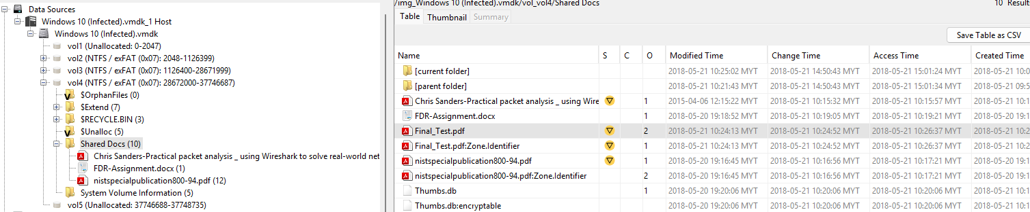

*Figure 75 Final_Test.pdf flagged as malicious file on VirusTotal*

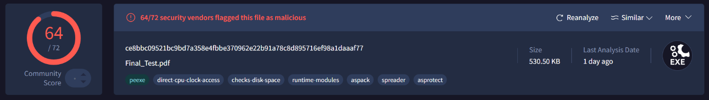

CHAPTER 5: TECHNICAL REPORT

**5.1** Executive Summary

The windows 10 file was analysed using autopsy and volatility workbench. Upon completion of analysing of the file, 13 malwares of three different types were found, Keylogger, Key Management Service (KMS) and Trojan. The keylogger malware recorded the user’s keystrokes, capturing sensitive information. The KMS malware opens backdoors for installation of malicious software. Lastly the Trojan malware performs harmful actions like stealing data, installing other malware etc. As a result of all 3 malwares, the user sensitive and valuable information has been captured, attackers have access to the device and backdoor to other malicious software have been added to the device making it a ticking time bomb.

**5.2** Relevant Findings

**5.2.1** Keylogger

During the forensic analysis that we did on the infected Windows 10 VM, we identified multiple files connected with a class of malware known as *keyloggers*. These are malicious programs that are designed to secretly record every input the user does on the keyboard, in order to capture sensitive data such as usernames, passwords, banking information, or confidential communication. The specific files that were identified were:

* filedat.dat
* win10drivetest(Demo).exe
* rsaws.exe
* wap.exe

The presence of these files strongly indicates that user was being actively monitored on his own device without the users consent or knowing. T The more dreaded variety of a keylogger will often have no interface: it silently gathers input data behind the user's back and then sends it to remote attackers. In fact, these avenues of intrusion go beyond the regular detection abilities and can stay active for a long time unbeknownst to the victim, presenting huge opportunities for data breaches and cases of identity theft.

Keyloggers can be installed through misleading download links, email attachments, or bundled with unauthorized software. In this case, the filenames suggest an attempt to disguise themselves as legitimate or technical tools (e.g., "win10drivetest" or "rsaws.exe"). This strategy is often used in order to mislead both users and antivirus software.

The consequences are grave as seen through business and customer aspects. In case the employees have used this infected machine to log in, send emails, access client data or other sacred business information, it is conceivable that the data was stolen. This not only exposes our internal systems to danger but also jeopardizes our customer faith and adherence to the regulations of data protection.

Immediate action was taken to isolate the device and remove the threats, but further investigation and monitoring of potentially compromised accounts and systems is strongly recommended.

**5.2.2** KMS

The other kind of suspicious files found in the infected machine is categorized as KMS tools which is supposed to be used in unauthorized software activation. The files that are accessed are:

* KMSCleaner.exe
* KMSAuto Net.exe
* TunMirror.exe
* FakeClient.exe
* KMSSS.exe

One of the most popular uses of these tools is to evade a Microsoft licensing system to validate one Window or office product when a valid copy is not available. This might appear as a minor breach at the first glance, in fact, it leads to serious cybersecurity threats. Such tools are un-official, are usually downloaded unofficially on unsafe sites and may also include malware, like a Trojan, backdoor or ransomware.

Here the appearance of executables of KMS indicates the possibility that somebody has tried to unlock Microsoft software on this machine in an unauthorized way. Worse still, those tools create a portal into more in-depth infections: attackers often implement KMS programs as vehicles to install more dangerous packages.

This is not just a technical problem, it is a liability, as a customer facing perspective or as a business leadership perspective. Using cracked software instruments might lead to punishment of the company legally, might leave a software warrantee useless as well as reinforces that there has been failure in IT management. Of more concern, it demonstrates a possible route of installing malicious code in our environment.

We suggest that the software licensing practices in all systems should be reviewed immediately, and we will insist that use of unauthorized tools should be banned. Also, the audit should be conducted on similar machines to check on compliance and integrity of security.

**5.2.3** Trojans

The worst find was the existence of the files with a very strong connection with Trojan Malware. Trojans are the dangerous programs that seem to be the genuine ones such as documents, installers, or utilities but as soon as they are launched malicious condes gets to work. The files which were detected as Trojans were:

* Final_Test.pdf.
* loder.exe
* updstoe.exe
* DLLInjector V2.exe

All these files are in the common form of a Trojan. As an example, theFileName.pdf file might look like a regular file with nothing wrong with it but they might in fact be trying to find an exploit on PDF reader to install malware. DLLInjector V2.exe is the most dangerous because it implies that interaction with DLL injection, a mean that enables malware to perform their activities in a very silent way inside other programs under use and permits malware to be virtually invisible within the remains of the other application programs.

The application of Trojan malware is related to the targeted application by the malware distributor. They can leave backdoors that allow them to exploit more, install other malicious software, steal information, or even make systems unusable. Considering the variety of executable files detected, is it possible that this infection was involved in a larger campaign that included spyware as well as manipulation of system at a high level.

This is a big red flag to organization. Trojans may violate the integrity of the system, break down the work and lead to the destruction of the clients data or intellectual property. The Trojan could have been from a Phishing email, fake download, and even a USB stick and all above need immediate consideration in our security awareness training and endpoint protection plans.

We Suggest a security audit, endpoint reimaging, password reset on affected users and enhanced monitoring of Indicators of Compromise (IoC) throughout the network. The necessity to have not only multi-layered protection but also robust antivirus, Endpoint Detection, and Response (EDR) tactics and educating employees on issues of encountering suspicious files should be reinforced by this incident as well.

**5.3** Steps to Mitigate Risks or Prevent Recurrence

**5.3.1** Stricter Control Over Software installation

Among the most obvious problems that were identified in the process of this case, there was the existence of suspicious tools such as KMSAuto Net and DLL injectors. These do not come on systems through accident but have to be downloaded whether with malicious intent of someone wishing to use the software in an illegal way or as part of a group of unsafe downloads.

What to do in order to avoid that:

* Latest restrictions should be placed on software installation by only authorized personnel. Ordinary users must not be capable to upload an execute executable files that are disapproved.
* Any request of third-part software needs to take an internal vetting process where we get to know the source of software, verify licenses, and ensure the program will be safe.
* We need to also use application white-listing, after applying it, only the permitted programs can run, and all other things are blocked by default.

**5.3.2** Better Endpoint Protection and Monitoring

Antivirus software is helpful, but it is not sufficient anymore. New malware is programmed not be detected by old and mainstream tools, even more so when it pretends to be a generic or even a legitimate program.

To keep up with theses dangers:

* We ought to buy an Endpoint Detection and Response (EDR) system. In contrast to simple antivirus, ERD tracks behavior and notices suspicious activity and an option to investigate swiftly.
* We will be able to see the warning signs soon enough with real-time alerts and logging in a central server so that out IT staff can intervene when a non-protocol file is trying to write keystroke activities or uploading information.
* Full scans must be set to run weekly in automatic mode, rather than being left to the users to run in manual mode.

**5.3.3** Mandatory User Training and Awareness

The finest security tools may be found null and void in case they are not knowledgeable on how they are being lured by attackers, The majority of malware especially Trojan and Keyloggers get installed in the systems because of someone accidentally clicking on a bad link, pretending file, or an email attachment.

To be able to counter this we suggest:

* Awareness Training on cybersecurity of staff once every quarter. It must be concise, interactive and target practical situations such as phishing spam mails, false downloads and insecure use of USBs.
* Conduct simulated phish to measure the employee's reaction to any suspicious emails and then feedback and learning.
* Guidelines and posters should be put in the working plcaes to remind people about digital hygiene such as not downloading unknown files or not clicking suspicious pop-ups.

CONCLUSION

The memory acquisition and forensic analysis performed on the compromised Windows 10 virtual machine demonstrated a high level of technical expertise, analytical skills, and investigative depth. Using standard tools such as Magnet Ram Capture, Volatility, and VirusTotal, the team successfully acquired images of the RAM and hard disk drives (HDD), preserving data integrity, and ensuring reliable forensic processing throughout the process. (Ben Filipkowski, 2025)

Subsequent image analysis revealed a set of suspicious files, such as KMSSS.exe, RtlUpd.EXE, win10drivetest(Demo).exe, and 15570-filedat.dat, all classified by leading security engines for malicious activity. These files exhibited characteristics such as persistence, debugging resistance, stealthy overlays, and data exfiltration, indicating coordinated malicious behaviour. By correlating static indicators with dynamic analysis and time-series correlation, the investigation revealed crucial evidence validating the system compromise and identifying potential malware vectors.

This work reinforced the importance of systematic investigation processes, including tool selection, evidence preservation, and the writing of structured technical reports. It also highlighted the need for continuous monitoring of evolving cyber threats and adversary techniques. Hands-on experience in memory acquisition and malware identification provided our team with the skills needed to handle real-world investigations with accuracy and confidence. (Deakin, 2025)

Ultimately, this research achieved the desired CLO3 learning objective by demonstrating the application of investigation methodologies to detect and report malicious activity on compromised systems. It also highlights the crucial role of memory analytics in modern incident response and demonstrates the need for organizations to adopt robust and proactive cybersecurity and digital forensics capabilities.

REFERENCES

Ben Filipkowski, T. R. (2025, May 9). *What is digital forensics and incident response (DFIR)?* Retrieved from FIELD EFFECT: https://fieldeffect.com/blog/digital-forensics-incident-response

Computer Forensics. (2024, March 6). *What is Digital Forensics? Phases of Digital Forensics in Cybersecurity*. Retrieved from EC-Council: https://www.eccouncil.org/cybersecurity-exchange/computer-forensics/what-is-digital-forensics/

Deakin, T. (2025, April 2025). *What is a chain of custody in cyber investigations and what role does it play in legal defence?* Retrieved from SRM: https://www.srm-solutions.com/blog/what-is-a-chain-of-custody-in-cyber-investigations-and-what-role-does-it-play-in-legal-defence/

*Digital Forensics in Cyber Security*. (2024, June 14). Retrieved from GeeksforGeeks: https://www.geeksforgeeks.org/computer-networks/digital-forensics-in-cyber-security/

Hessler, S. (2024, July 22). *What is the “Chain of Custody” & Why Does it Matter?* Retrieved from Hessler Law PC: https://www.hesslerlaw.com/blog/what-is-the-chain-of-custody-why-does-it-matter/

Hybird Analysis. (n.d.). *Hybrid Analysis*. Retrieved from Hybird Analysis: https://www.hybrid-analysis.com/

*Magnet RAM Capture*. (n.d.). Retrieved from MAGNET FORENSICS: https://www.magnetforensics.com/resources/magnet-ram-capture/

NirSoft. (n.d.). *HashMyFiles v2.50 - Calculate MD5/SHA1/CRC32/SHA-256/SHA-512/SHA-384 hashes of your files*. Retrieved from NirSoft: https://www.nirsoft.net/utils/hash_my_files.html

The Volatility Foundation. (2025, May 16). *Announcing the Official Parity Release of Volatility 3!* Retrieved from volatilityfoundation: https://volatilityfoundation.org/announcing-the-official-parity-release-of-volatility-3/

virustotal. (n.d.). *How it works*. Retrieved from virustotal: https://docs.virustotal.com/docs/how-it-works

VMware. (n.d.). *Fusion and Workstation*. Retrieved from VMware by Broadcom: https://www.vmware.com/products/desktop-hypervisor/workstation-and-fusion

WORKLOAD MATRIX

|  |  |  |
| --- | --- | --- |
| NAME | TASK | SIGNATURE |
| AHMED MIRAHUSAIN ALVI (TP084807) | * **4.1 Ram Analysis using PassMark Volatility Workbench V3.0** * **Workload Matrix** | *AHMED ALVI* |
| MOHAMMED YOUSEF MOHAMMED MOHAMMED (TP085042) | * **3.1 Load Infected Windows 10 using VMware.** * **References** | **MO** |
| SULTAN ABDULLA OMAR TAKRORI (TP085327) | * **1.0 Introduction** * **2.1 Forensic Tools Used** * **3.3 Loading MRC Image file into Volatility Workbench V3.0** | **STK** |
| MAHRUS SHAMSUL AHSAN (TP085562) | * **3.3 New Case Creation and HDD data extraction using Autopsy 4.22.1** * **5.1 Executive Summary** | ***~~MSA~~*** |
| ABDALLAH MOHAMED MAHMOUD MOHAMED MAHMOUD (TP085097) | * **3.2 Capture Memory using Magnet Ram Capture** * **4.2.13 Final_Test.pdf** * **5.2 Relevant Findings** * **5.3 Steps to mitigate Risks or Prevent Recurrence** | **Abdo** |
| MOHAMED ABDIFATAH ALI (TP082459) | * **2.2 Data Acquisition** * **4.1 Ram Analysis using PassMark Volatility Workbench V3.0** |  |
| MOHAMED ABA SAID (TP082376) | * **4.2.9 KMSSS.exe** * **4.2.10 lode.exe** * **4.2.11 win10drivetest (Demo).exe** * **4.2.12 filedat.dat** * **Conclusion** |  |
| BADR MAHDI MUBARAK AL-AMRI (TP083084) | * **4.2.1 wap.exe** * **4.2.2 rsaws.exe** * **4.2.3 FakeClient.exe** * **4.2.4 TunMirror.exe** * **4.2.5 KMSAuto Net.exe** * **4.2.6 DLLInjectormv2.exe** * **4.2.7 Updsto.exe** * **4.2.8 KMSClearner.exe** |  |